NAME : SARTH NAROLA
ROLL NO. : 23BCE194
……………………………………………………………………………………………………………………………………………….
NAME : NEVIL ANGHAN
ROLL NO. : 23BCE195
……………………………………………………………………………………………………………………………………………….
A Project Report On

E-Commerce Sales Analysis and Visualization using Global Superstore Dataset

Data Analysis and Visualization



Department of Computer Science and Technology

Nirma University

October 2025

Final Report on E-Commerce Sales Analysis and Visualization using Global Superstore Dataset

Q1. Identify the Problem for your Application Domain :-

Since our dataset is the Global Superstore dataset, our application domain is E-Commerce / Retail Sales Analytics.:
Problem Identification
The problem is that Global Superstore, being a large-scale international retail company, generates huge volumes of transactional data across different regions, categories, and customer segments. However, the raw data alone doesn’t provide clear insights.
The main problem is:
- Understanding sales and profit trends across different regions, markets, and product categories.
- Identifying loss-making transactions due to high discounts or shipping costs.
- Recognizing customer segments and regions that contribute most to profit.
- Improving decision-making in terms of pricing, shipping mode, inventory, and customer targeting.

Q2. Find the Dataset with raw data :-

The dataset with raw data is Global_Superstore.csv is related to E-Commerce Sales.
This raw dataset contains the unprocessed transactional records from the Global Superstore, including fields such as:
- Order ID
- Order Date, Ship Date, Ship Mode
- Customer Name, Segment
- City, Country, Region, Market
- Product Category, Sub-Category, Product Name
- Sales, Quantity, Discount, Profit, Shipping Cost
- Order Priority
Since this is the raw data, it has not yet been cleaned, aggregated, or analyzed.
This dataset will be the starting point for data preprocessing, visualization, and analysis in our project.

Here’s the summary of our raw dataset:
- Number of rows (records): 51,290
- Number of columns (attributes): 24
This means our dataset contains 51,290 sales transactions with 24 features.

Q3. Set the objectives for the study :-

Objectives of the Study
- Sales and Profit Analysis
  - To analyze sales and profit trends across regions, markets, and customer segments.
  - To identify high-performing and low-performing product categories.
- Customer Segmentation
  - To study different customer segments (Consumer, Corporate, Home Office) and evaluate their contribution to overall sales and profit.
  - To recognize key customers who contribute significantly to revenue.
- Geographical Insights
  - To compare sales and profit across countries, cities, and regions.
  - To identify regions with high sales but low profit (indicating cost or discount issues).
- Impact of Discounts and Shipping Costs
  - To evaluate how discounts affect profitability.
  - To analyze the effect of shipping costs and shipping modes on overall revenue.
- Product-Level Insights
  - To identify the top-selling and least-selling products.
  - To check which sub-categories drive profit or cause losses.
- Decision-Making Support
  - To provide insights that can help in optimizing pricing strategies, reducing losses, and improving logistics.
  - To recommend strategies for maximizing profitability and customer satisfaction.

Q4. Write the scope of the study and identify the stakeholders :-

The scope of our study is limited to analyzing the Global Superstore sales dataset to derive insights that support decision-making in the retail business domain.
It includes:
- Studying sales, profit, and discount patterns across regions, markets, and customer segments.
- Evaluating the impact of shipping modes and shipping costs on profitability.
- Identifying top-performing and underperforming products and categories.
- Segmenting customers based on their purchasing behavior and profitability contribution.
- Providing insights to improve pricing strategies, promotional offers, and logistics planning.
The study will focus only on the data provided in the Global Superstore dataset. It will not include external factors like competitor analysis, real-time inventory management, or seasonal/global economic conditions, as these are beyond the dataset.

Stakeholders
- Business Managers / Executives
  - To make strategic decisions regarding pricing, discounting, and product focus.
- Sales & Marketing Teams
  - To design better promotional campaigns, target profitable segments, and improve customer satisfaction.
- Supply Chain & Logistics Teams
  - To optimize shipping modes and reduce costs while ensuring timely delivery.
- Financial Analysts
  - To evaluate profitability and identify loss-making transactions for better financial planning.
- Customers (Indirect Stakeholders)
  - They benefit from improved services, better product availability, and optimized pricing strategies.

Q5. Know your data characteristics and make the plots to learn about your data characteristics :-

Data Characteristics
- Number of rows (records): 51,290
- Number of columns (attributes): 24
- Column names: Row ID, Order ID, Order Date, Ship Date, Ship Mode, Customer ID, Customer Name, Segment, City, State, Country, Postal Code, Market, Region, Product ID, Category, Sub-Category, Product Name, Sales, Quantity, Discount, Profit, Shipping Cost, Order Priority
- Data types:
  - 17 categorical/object features (like Customer Name, Category, Region, etc.)
  - 5 numerical features (Sales, Discount, Profit, Shipping Cost, Quantity)
  - 2 integer identifiers (Row ID, Postal Code)

Attribute Identification table
Feature Name | Description | Type | Scale
Row ID | Unique identifier for each row | Numerical | Discrete / Ratio
Order ID | Unique identifier for each order | Categorical | Nominal
Order Date | Date when the order was placed | Date/Time | Interval
Ship Date | Date when the order was shipped | Date/Time | Interval
Ship Mode | Shipping mode selected for the order | Categorical | Nominal
Customer ID | Unique identifier for each customer | Categorical | Nominal
Customer Name | Name of the customer | Categorical | Nominal
Segment | Customer segment (Consumer, Corporate, Home Office) | Categorical | Nominal
City | City where the customer is located | Categorical | Nominal
State | State where the customer is located | Categorical | Nominal
Country | Country where the customer is located | Categorical | Nominal
Postal Code | Postal code of the customer location | Numerical | Discrete / Ratio
Market | Market classification (e.g., APAC, EU, US) | Categorical | Nominal
Region | Region classification (e.g., East, West, Central) | Categorical | Nominal
Product ID | Unique identifier for each product | Categorical | Nominal
Category | Main product category (Furniture, Technology, etc.) | Categorical | Nominal
Sub-Category | Sub-category of the product | Categorical | Nominal
Product Name | Name of the product | Categorical | Nominal
Sales | Sales revenue from the transaction | Numerical | Continuous / Ratio
Quantity | Quantity of items sold | Numerical | Discrete / Ratio
Discount | Discount applied to the transaction | Numerical | Continuous / Ratio
Profit | Profit (or loss) from the transaction | Numerical | Continuous / Ratio
Shipping Cost | Cost incurred in shipping the product | Numerical | Continuous / Ratio
Order Priority | Priority assigned to the order | Categorical | Ordinal

Plots to learn about your data characteristics

# Import necessary libraries
import pandas as pd
import matplotlib.pyplot as plt
import seaborn as sns
import numpy as np

# Set style for better-looking plots
sns.set_style('whitegrid')
plt.rcParams['figure.figsize'] = (12, 6)

# Load the data
df = pd.read_csv('Global_Superstore.csv', encoding='latin-1')
print(f"Dataset shape: {df.shape}")
print(f"\nColumns: {df.columns.tolist()}")

# ============================================================================
# 1. Basic Data Overview
# ============================================================================

# Display first few rows
print("\nFirst 5 rows of data:")
print(df.head())

# Data types and missing values
print("\nData Info:")
df.info()
print("\nMissing Values:")
print(df.isnull().sum())

# Statistical summary
print("\nStatistical Summary:")
print(df.describe())

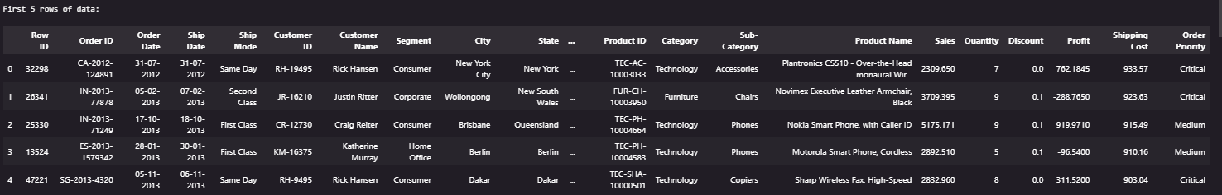
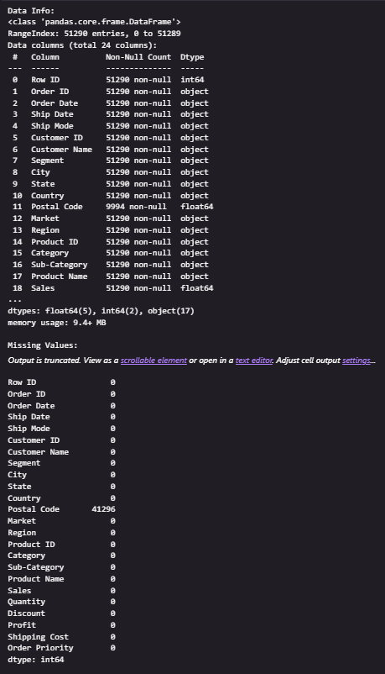
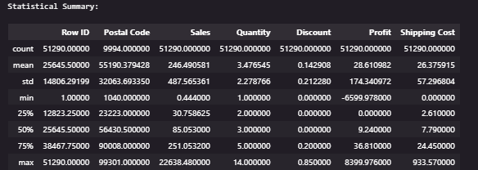
# ============================================================================
# 2. Distribution Plots - Understanding how values are spread
# ============================================================================

# Sales Distribution - Histogram
plt.figure(figsize=(12, 5))

plt.subplot(1, 2, 1)
plt.hist(df['Sales'], bins=50, color='skyblue', edgecolor='black')
plt.title('Sales Distribution', fontsize=14, fontweight='bold')
plt.xlabel('Sales Amount')
plt.ylabel('Frequency')
plt.grid(axis='y', alpha=0.3)

plt.subplot(1, 2, 2)
plt.hist(df['Profit'], bins=50, color='lightcoral', edgecolor='black')
plt.title('Profit Distribution', fontsize=14, fontweight='bold')
plt.xlabel('Profit Amount')
plt.ylabel('Frequency')
plt.grid(axis='y', alpha=0.3)

plt.tight_layout()
plt.show()
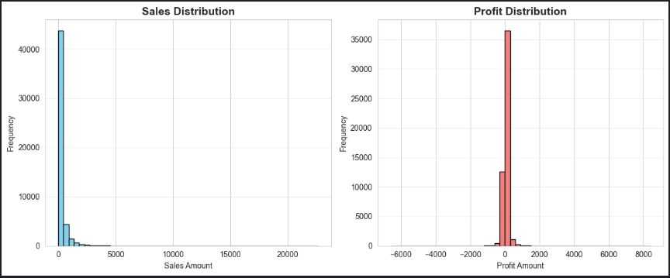
# Box Plot - Identifying outliers
fig, axes = plt.subplots(1, 3, figsize=(15, 5))

axes[0].boxplot(df['Sales'])
axes[0].set_title('Sales Box Plot', fontweight='bold')
axes[0].set_ylabel('Sales')

axes[1].boxplot(df['Profit'])
axes[1].set_title('Profit Box Plot', fontweight='bold')
axes[1].set_ylabel('Profit')

axes[2].boxplot(df['Quantity'])
axes[2].set_title('Quantity Box Plot', fontweight='bold')
axes[2].set_ylabel('Quantity')

plt.tight_layout()
plt.show()
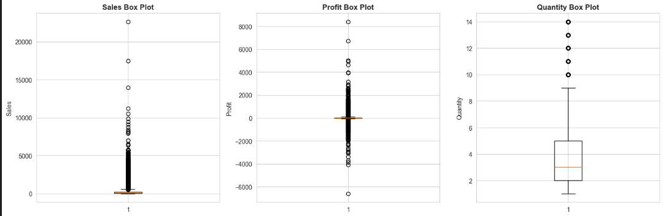
# ============================================================================
# 3. Categorical Data Analysis - Exploring categories and segments
# ============================================================================

# Count Plot - Category Distribution
plt.figure(figsize=(10, 6))
category_counts = df['Category'].value_counts()
plt.bar(category_counts.index, category_counts.values, color=['#FF6B6B', '#4ECDC4', '#45B7D1'])
plt.title('Number of Orders by Category', fontsize=14, fontweight='bold')
plt.xlabel('Category')
plt.ylabel('Count')
plt.xticks(rotation=0)
for i, v in enumerate(category_counts.values):
plt.text(i, v + 100, str(v), ha='center', fontweight='bold')
plt.show()
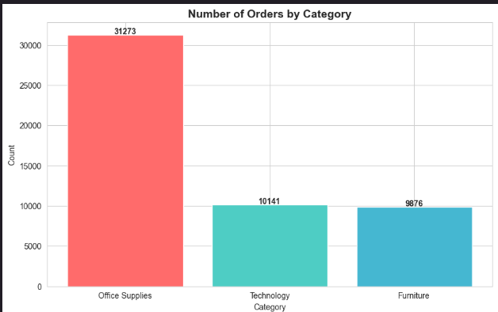
# Pie Chart - Market Distribution
plt.figure(figsize=(10, 8))
market_counts = df['Market'].value_counts()
colors = plt.cm.Set3(range(len(market_counts)))
plt.pie(market_counts.values, labels=market_counts.index, autopct='%1.1f%%',
startangle=90, colors=colors)
plt.title('Market Distribution', fontsize=14, fontweight='bold')
plt.axis('equal')
plt.show()
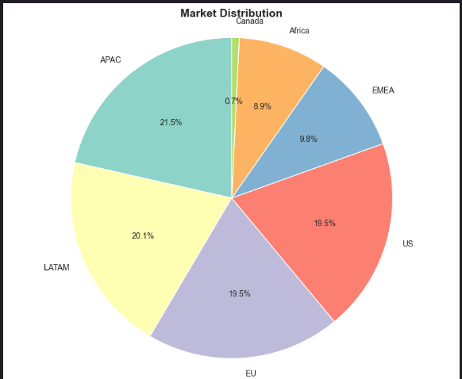
# Segment Analysis
plt.figure(figsize=(10, 6))
segment_counts = df['Segment'].value_counts()
plt.barh(segment_counts.index, segment_counts.values, color=['#95E1D3', '#F38181', '#EAFFD0'])
plt.title('Customer Segment Distribution', fontsize=14, fontweight='bold')
plt.xlabel('Count')
plt.ylabel('Segment')
for i, v in enumerate(segment_counts.values):
plt.text(v + 100, i, str(v), va='center', fontweight='bold')
plt.show()
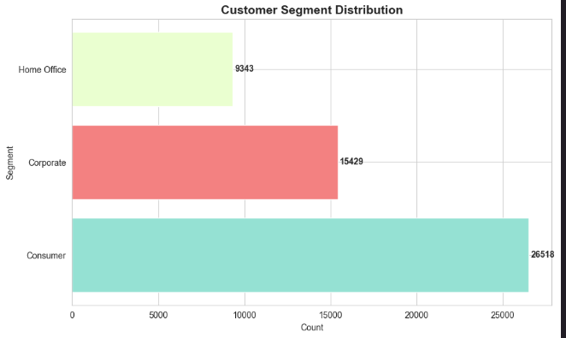# ============================================================================
# 4. Sales Analysis - Understanding revenue patterns
# ============================================================================

# Sales by Category
plt.figure(figsize=(12, 6))
sales_by_category = df.groupby('Category')['Sales'].sum().sort_values(ascending=False)
plt.bar(sales_by_category.index, sales_by_category.values, color=['#FF6B6B', '#4ECDC4', '#45B7D1'])
plt.title('Total Sales by Category', fontsize=14, fontweight='bold')
plt.xlabel('Category')
plt.ylabel('Total Sales ($)')
plt.ticklabel_format(style='plain', axis='y')
for i, v in enumerate(sales_by_category.values):
plt.text(i, v + 10000, f'${v:,.0f}', ha='center', fontweight='bold')
plt.show()
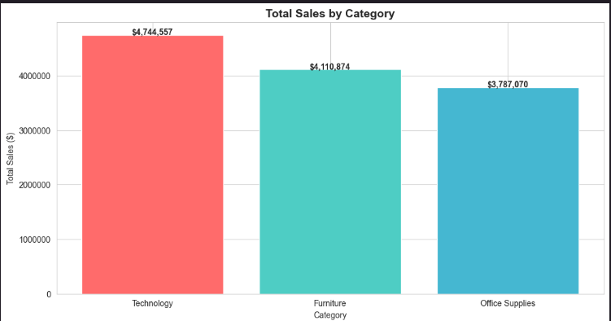
# Top 10 Sub-Categories by Sales
plt.figure(figsize=(12, 6))
top_subcategories = df.groupby('Sub-Category')['Sales'].sum().sort_values(ascending=False).head(10)
plt.barh(range(len(top_subcategories)), top_subcategories.values, color='coral')
plt.yticks(range(len(top_subcategories)), top_subcategories.index)
plt.title('Top 10 Sub-Categories by Sales', fontsize=14, fontweight='bold')
plt.xlabel('Total Sales ($)')
plt.ylabel('Sub-Category')
plt.gca().invert_yaxis()
plt.show()
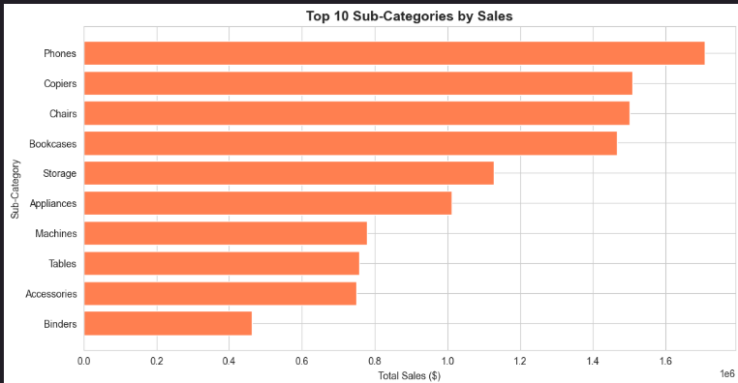
# Sales by Market
plt.figure(figsize=(12, 6))
sales_by_market = df.groupby('Market')['Sales'].sum().sort_values(ascending=False)
colors = plt.cm.viridis(np.linspace(0, 1, len(sales_by_market)))
plt.bar(sales_by_market.index, sales_by_market.values, color=colors)
plt.title('Total Sales by Market', fontsize=14, fontweight='bold')
plt.xlabel('Market')
plt.ylabel('Total Sales ($)')
plt.xticks(rotation=45)
for i, v in enumerate(sales_by_market.values):
plt.text(i, v + 10000, f'${v:,.0f}', ha='center', fontweight='bold', rotation=0)
plt.tight_layout()
plt.show()
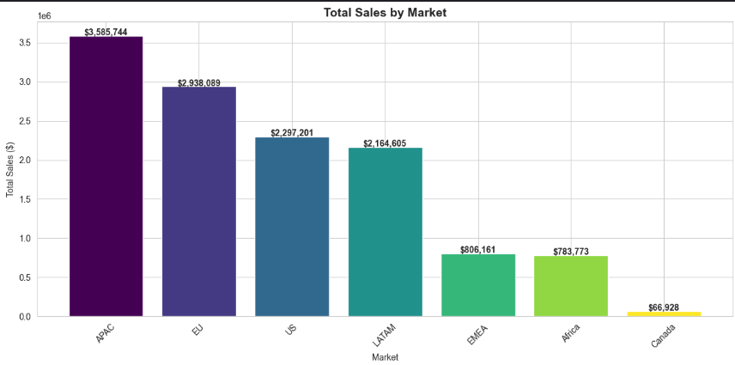
# ============================================================================
# 5. Profit Analysis - Understanding profitability
# ============================================================================

# Profit by Category
plt.figure(figsize=(12, 6))
profit_by_category = df.groupby('Category')['Profit'].sum().sort_values(ascending=False)
colors = ['green' if x > 0 else 'red' for x in profit_by_category.values]
plt.bar(profit_by_category.index, profit_by_category.values, color=colors)
plt.title('Total Profit by Category', fontsize=14, fontweight='bold')
plt.xlabel('Category')
plt.ylabel('Total Profit ($)')
plt.axhline(y=0, color='black', linestyle='-', linewidth=0.5)
for i, v in enumerate(profit_by_category.values):
plt.text(i, v + 5000, f'${v:,.0f}', ha='center', fontweight='bold')
plt.show()
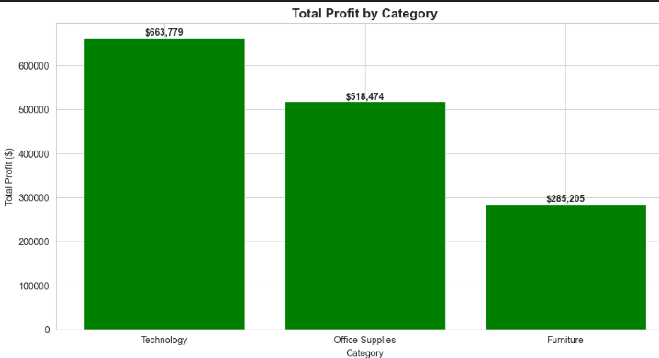
# Profit Margin by Category
category_stats = df.groupby('Category').agg({'Sales': 'sum', 'Profit': 'sum'})
category_stats['Profit_Margin'] = (category_stats['Profit'] / category_stats['Sales']) * 100

plt.figure(figsize=(10, 6))
plt.bar(category_stats.index, category_stats['Profit_Margin'], color=['#FFB6C1', '#87CEEB', '#98FB98'])
plt.title('Profit Margin by Category (%)', fontsize=14, fontweight='bold')
plt.xlabel('Category')
plt.ylabel('Profit Margin (%)')
plt.axhline(y=0, color='black', linestyle='-', linewidth=0.5)
for i, v in enumerate(category_stats['Profit_Margin'].values):
plt.text(i, v + 0.5, f'{v:.1f}%', ha='center', fontweight='bold')
plt.show()
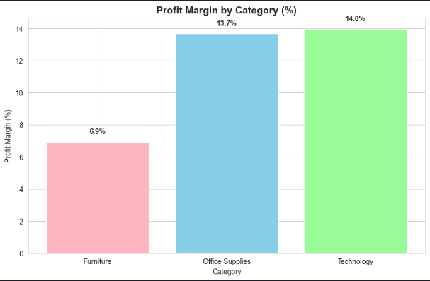
# ============================================================================
# 6. Relationship Analysis - How variables relate to each other
# ============================================================================

# Scatter Plot - Sales vs Profit
plt.figure(figsize=(12, 6))
plt.scatter(df['Sales'], df['Profit'], alpha=0.5, c=df['Discount'], cmap='coolwarm')
plt.colorbar(label='Discount')
plt.title('Sales vs Profit (colored by Discount)', fontsize=14, fontweight='bold')
plt.xlabel('Sales ($)')
plt.ylabel('Profit ($)')
plt.axhline(y=0, color='red', linestyle='--', linewidth=1, alpha=0.5)
plt.grid(alpha=0.3)
plt.show()
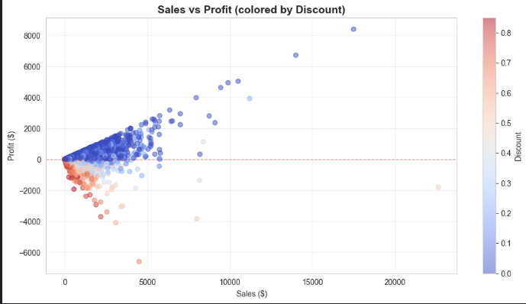
# Correlation Heatmap
plt.figure(figsize=(10, 8))
numeric_cols = ['Sales', 'Quantity', 'Discount', 'Profit', 'Shipping Cost']
correlation = df[numeric_cols].corr()
sns.heatmap(correlation, annot=True, cmap='coolwarm', center=0,
square=True, linewidths=1, fmt='.2f')
plt.title('Correlation Heatmap', fontsize=14, fontweight='bold')
plt.tight_layout()
plt.show()
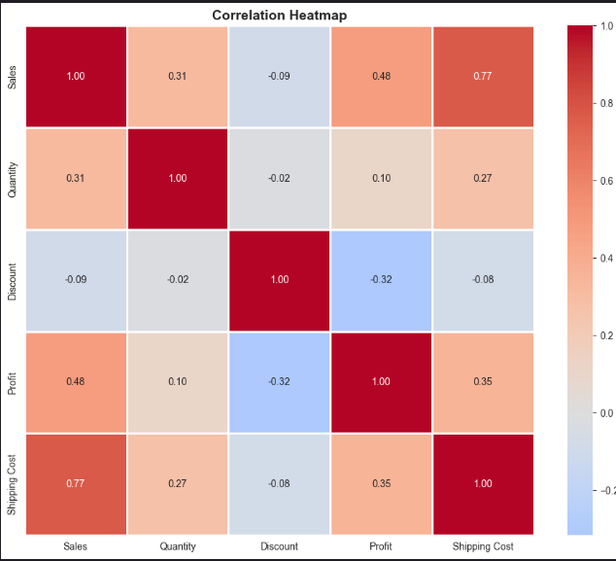
# Quantity vs Sales by Category
plt.figure(figsize=(12, 6))
for category in df['Category'].unique():
category_data = df[df['Category'] == category]
plt.scatter(category_data['Quantity'], category_data['Sales'],
label=category, alpha=0.6, s=50)
plt.title('Quantity vs Sales by Category', fontsize=14, fontweight='bold')
plt.xlabel('Quantity')
plt.ylabel('Sales ($)')
plt.legend()
plt.grid(alpha=0.3)
plt.show()
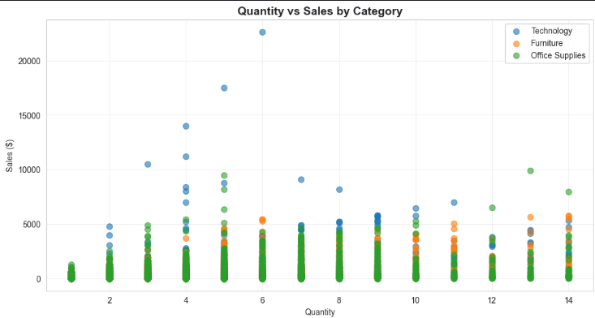
# ============================================================================
# 7. Discount Impact Analysis
# ============================================================================

# Discount Distribution
plt.figure(figsize=(12, 5))

plt.subplot(1, 2, 1)
plt.hist(df['Discount'], bins=20, color='orange', edgecolor='black')
plt.title('Discount Distribution', fontsize=14, fontweight='bold')
plt.xlabel('Discount Rate')
plt.ylabel('Frequency')

plt.subplot(1, 2, 2)
discount_bins = pd.cut(df['Discount'], bins=[0, 0.1, 0.2, 0.3, 1.0],
labels=['0-10%', '10-20%', '20-30%', '30%+'])
avg_profit = df.groupby(discount_bins)['Profit'].mean()
plt.bar(range(len(avg_profit)), avg_profit.values, color='lightgreen', edgecolor='black')
plt.xticks(range(len(avg_profit)), avg_profit.index)
plt.title('Average Profit by Discount Range', fontsize=14, fontweight='bold')
plt.xlabel('Discount Range')
plt.ylabel('Average Profit ($)')
plt.axhline(y=0, color='red', linestyle='--', linewidth=1)

plt.tight_layout()
plt.show()
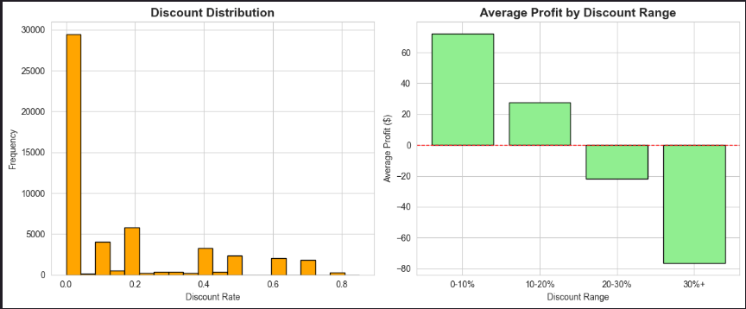
# ============================================================================
# 8. Shipping Analysis
# ============================================================================
# Ship Mode Distribution
plt.figure(figsize=(12, 5))

plt.subplot(1, 2, 1)
ship_mode_counts = df['Ship Mode'].value_counts()
plt.pie(ship_mode_counts.values, labels=ship_mode_counts.index, autopct='%1.1f%%',
startangle=90, colors=plt.cm.Pastel1(range(len(ship_mode_counts))))
plt.title('Ship Mode Distribution', fontsize=14, fontweight='bold')

plt.subplot(1, 2, 2)
avg_shipping = df.groupby('Ship Mode')['Shipping Cost'].mean().sort_values(ascending=False)
plt.barh(range(len(avg_shipping)), avg_shipping.values, color='steelblue')
plt.yticks(range(len(avg_shipping)), avg_shipping.index)
plt.title('Average Shipping Cost by Mode', fontsize=14, fontweight='bold')
plt.xlabel('Average Shipping Cost ($)')
plt.gca().invert_yaxis()

plt.tight_layout()
plt.show()
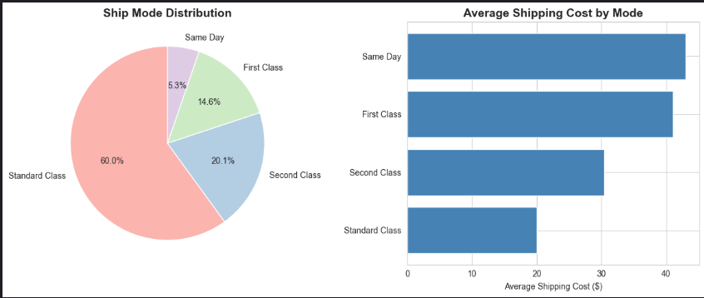
# ============================================================================
# 9. Geographic Analysis
# ============================================================================

# Top 10 Countries by Sales
plt.figure(figsize=(12, 6))
top_countries = df.groupby('Country')['Sales'].sum().sort_values(ascending=False).head(10)
plt.barh(range(len(top_countries)), top_countries.values, color='teal')
plt.yticks(range(len(top_countries)), top_countries.index)
plt.title('Top 10 Countries by Sales', fontsize=14, fontweight='bold')
plt.xlabel('Total Sales ($)')
plt.gca().invert_yaxis()
plt.tight_layout()
plt.show()
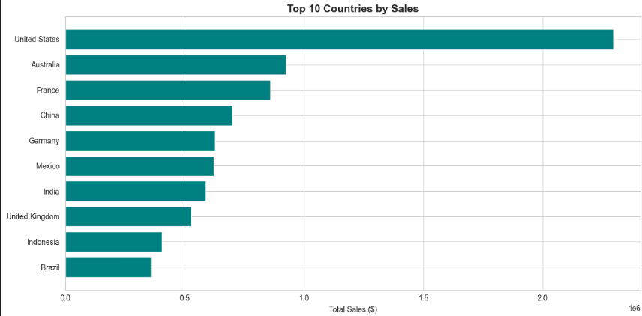
# Region Performance
region_stats = df.groupby('Region').agg({
'Sales': 'sum',
'Profit': 'sum',
'Order ID': 'count'
}).sort_values('Sales', ascending=False).head(10)

fig, axes = plt.subplots(1, 2, figsize=(15, 6))

axes[0].barh(range(len(region_stats)), region_stats['Sales'].values, color='skyblue')
axes[0].set_yticks(range(len(region_stats)))
axes[0].set_yticklabels(region_stats.index)
axes[0].set_title('Top 10 Regions by Sales', fontweight='bold')
axes[0].set_xlabel('Total Sales ($)')
axes[0].invert_yaxis()

axes[1].barh(range(len(region_stats)), region_stats['Profit'].values,
color=['green' if x > 0 else 'red' for x in region_stats['Profit'].values])
axes[1].set_yticks(range(len(region_stats)))
axes[1].set_yticklabels(region_stats.index)
axes[1].set_title('Top 10 Regions by Profit', fontweight='bold')
axes[1].set_xlabel('Total Profit ($)')
axes[1].axvline(x=0, color='black', linestyle='-', linewidth=0.5)
axes[1].invert_yaxis()

plt.tight_layout()
plt.show()
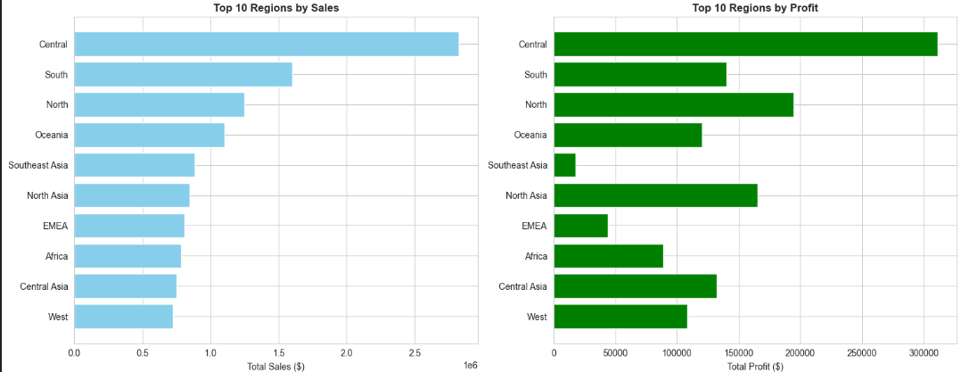

Q6. List the questionnaire/needs of each stakeholder :-
1) Business Managers / Executives
- Which regions, markets, and product categories are most profitable?
- Where are we incurring losses and why?
- What are the overall sales and profit trends over time?
- How should resources be allocated for maximum ROI?

2) Sales & Marketing Teams
- Which customer segments generate the most revenue?
- Which products should be promoted or discounted?
- How do discounts affect profitability?
- What are the seasonal sales patterns?

3) Supply Chain & Logistics Teams
- Which shipping modes are most cost-effective?
- How does shipping cost vary across regions?
- Where are delays or high costs affecting profitability?
- What logistics strategies can reduce losses?

4) Financial Analysts
- What is the contribution margin of different categories and regions?
- Where are discounts leading to losses?
- Which transactions have negative profit margins?
- How can cost control improve net profit?

5) Customers (Indirect Stakeholders)
- Will they receive products faster with efficient shipping modes?
- Can they get better pricing or fair discounts?
- Will the company maintain good product availability?
- Are promotions tailored to their needs?

Q7. perform the data preprocessing on a need basis
import pandas as pd
import numpy as np

# ============================================================================
# Load Data
# ============================================================================

print("GLOBAL SUPERSTORE DATA PREPROCESSING")

# Load the data (with encoding handling)
df = pd.read_csv('Global_Superstore.csv', encoding='latin-1')

print(f"\nTotal rows: {len(df)}")
print(f"Total columns: {len(df.columns)}")
print("\nColumn names and types:")
print(df.dtypes)
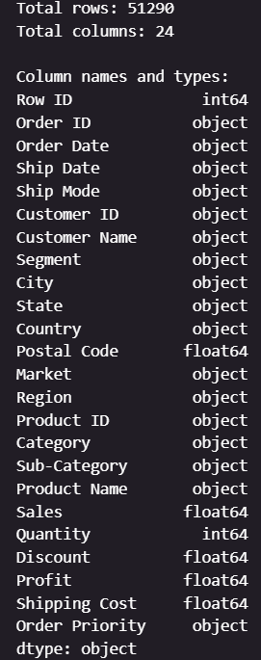
# ============================================================================
# Check for Missing Values
# ============================================================================

print("\nMISSING VALUES CHECK")

missing_values = df.isnull().sum()
print(missing_values[missing_values > 0])
if missing_values.sum() == 0:
print("No missing values found!")

# ============================================================================
# Handle Missing Postal Codes
# ============================================================================

if df['Postal Code'].isnull().sum() > 0:
print(f"\nPostal Code has {df['Postal Code'].isnull().sum()} missing values")
print("Filling with 'Unknown'")
df['Postal Code'] = df['Postal Code'].fillna('Unknown')

# ============================================================================
# Convert Date Columns
# ============================================================================

print("\nCONVERTING DATE COLUMNS")

df['Order Date'] = pd.to_datetime(df['Order Date'], format='%d-%m-%Y')
df['Ship Date'] = pd.to_datetime(df['Ship Date'], format='%d-%m-%Y')
print("Date columns converted to datetime format")

# ============================================================================
# Create Derived Columns
# ============================================================================

print("\nCREATING DERIVED COLUMNS")

# Shipping time in days
df['Shipping_Days'] = (df['Ship Date'] - df['Order Date']).dt.days
print("Created: Shipping_Days")

# Extract year, month, quarter
df['Order_Year'] = df['Order Date'].dt.year
df['Order_Month'] = df['Order Date'].dt.month
df['Order_Quarter'] = df['Order Date'].dt.quarter
print("Created: Order_Year, Order_Month, Order_Quarter")

# Profit margin percentage
df['Profit_Margin'] = (df['Profit'] / df['Sales']) * 100
print("Created: Profit_Margin")

# Profit category
df['Profit_Category'] = pd.cut(df['Profit'],
bins=[-np.inf, 0, 100, 500, np.inf],
labels=['Loss', 'Low Profit', 'Medium Profit', 'High Profit'])
print("Created: Profit_Category")

# ============================================================================
# Remove Duplicates
# ============================================================================

print("\nCHECKING FOR DUPLICATES")

duplicates = df.duplicated().sum()
print(f"Duplicate rows found: {duplicates}")
if duplicates > 0:
df = df.drop_duplicates()
print(f"Removed {duplicates} duplicate rows")
else:
print("No duplicates found")
# ============================================================================
# Outlier Detection
# ============================================================================

print("\nOUTLIER DETECTION (IQR Method)")

def detect_outliers_iqr(data, column):
"""Detect outliers using Interquartile Range method"""
Q1 = data[column].quantile(0.25)
Q3 = data[column].quantile(0.75)
IQR = Q3 - Q1
lower_bound = Q1 - 1.5 * IQR
upper_bound = Q3 + 1.5 * IQR
outliers = data[(data[column] < lower_bound) | (data[column] > upper_bound)]
return len(outliers)

for col in ['Sales', 'Profit', 'Quantity', 'Discount']:
outlier_count = detect_outliers_iqr(df, col)
print(f"{col}: {outlier_count} outliers detected")
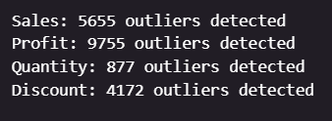
# ============================================================================
# Data Validation
# ============================================================================

print("\nDATA VALIDATION")

# Check for negative quantities
negative_qty = df[df['Quantity'] < 0]
print(f"Negative quantities: {len(negative_qty)}")

# Check for invalid discounts (should be between 0 and 1)
invalid_discount = df[(df['Discount'] < 0) | (df['Discount'] > 1)]
print(f"Invalid discounts: {len(invalid_discount)}")

# ============================================================================
# Save Preprocessed Data
# ============================================================================

print("\nSAVING PREPROCESSED DATA")

df.to_csv('Global_Superstore_Preprocessed.csv', index=False)
print("Saved to: Global_Superstore_Preprocessed.csv")

# ============================================================================
# Summary Statistics
# ============================================================================

print("\nSUMMARY STATISTICS")

print("\nNumerical columns summary:")
print(df[['Sales', 'Quantity', 'Discount', 'Profit', 'Shipping Cost']].describe())
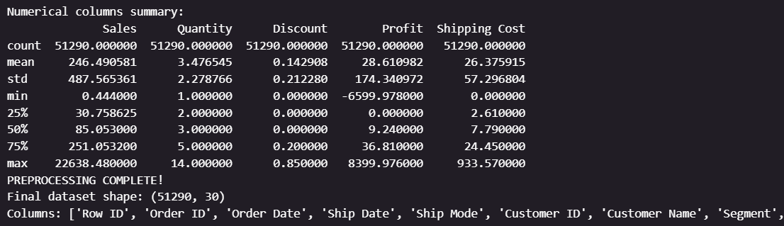

Q8. Design the dashboard for each stakeholder as per their need using tableau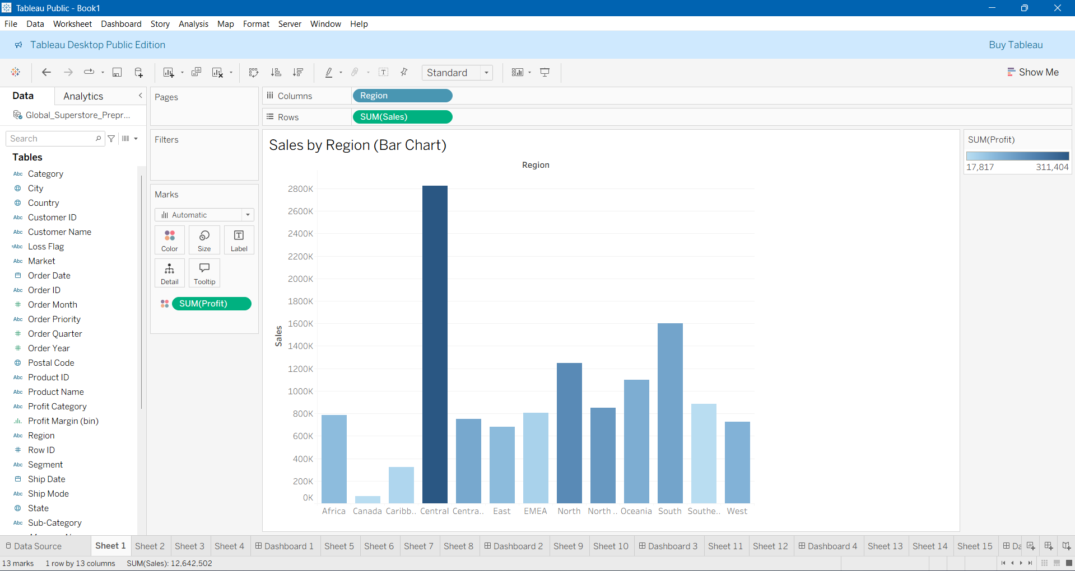
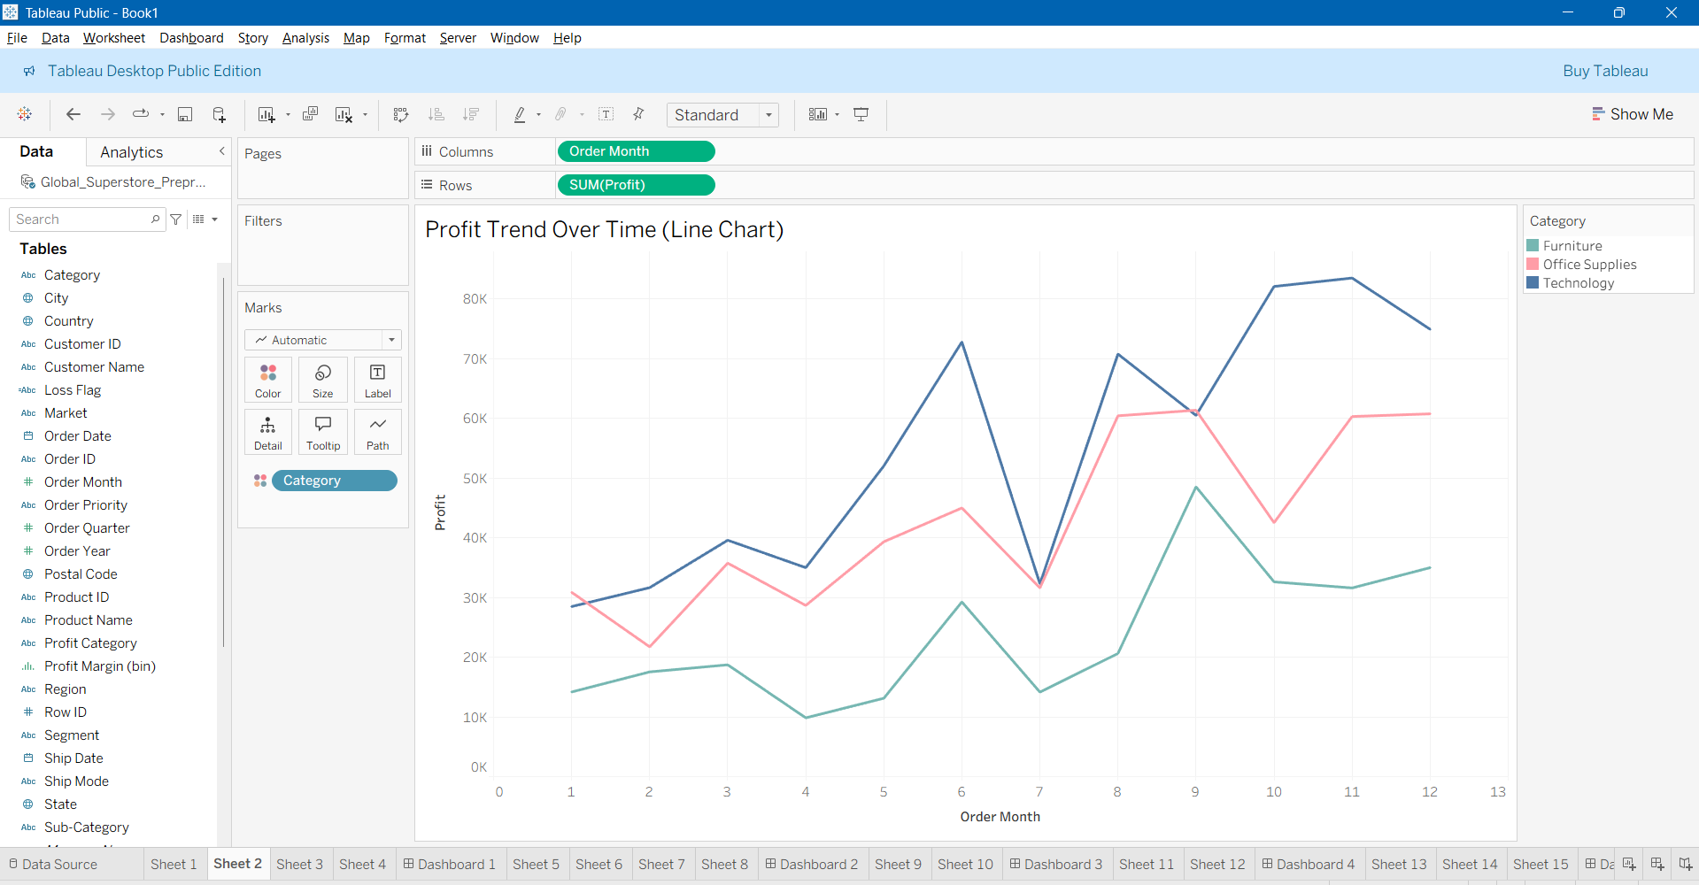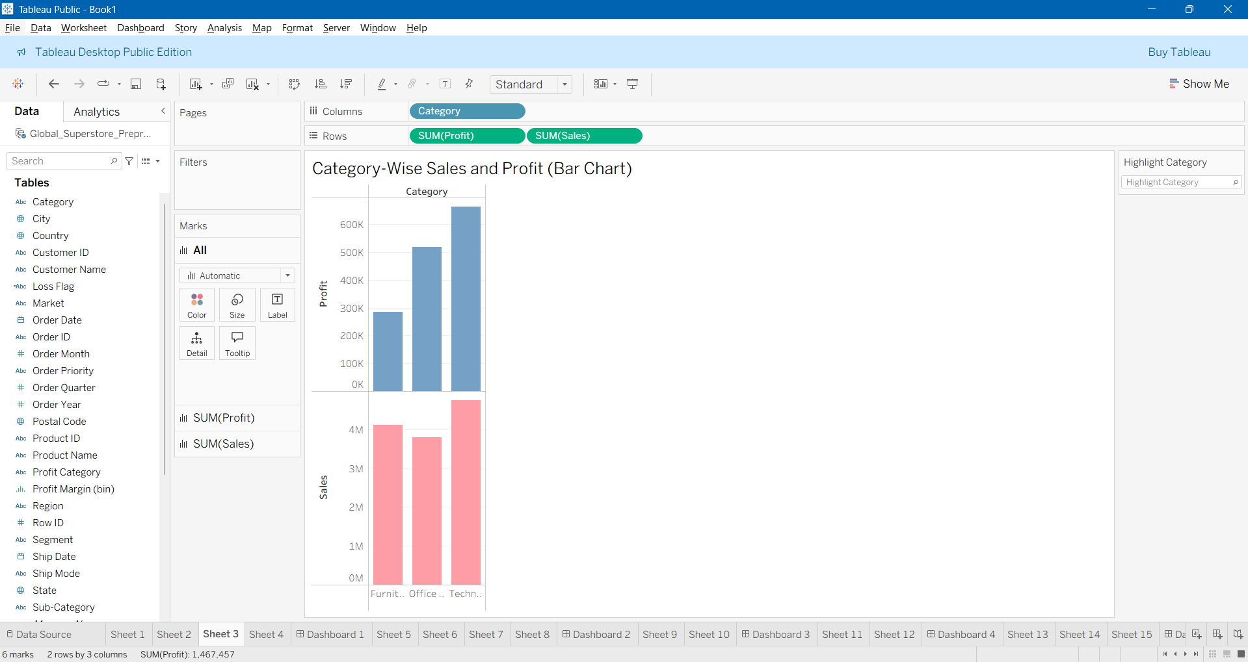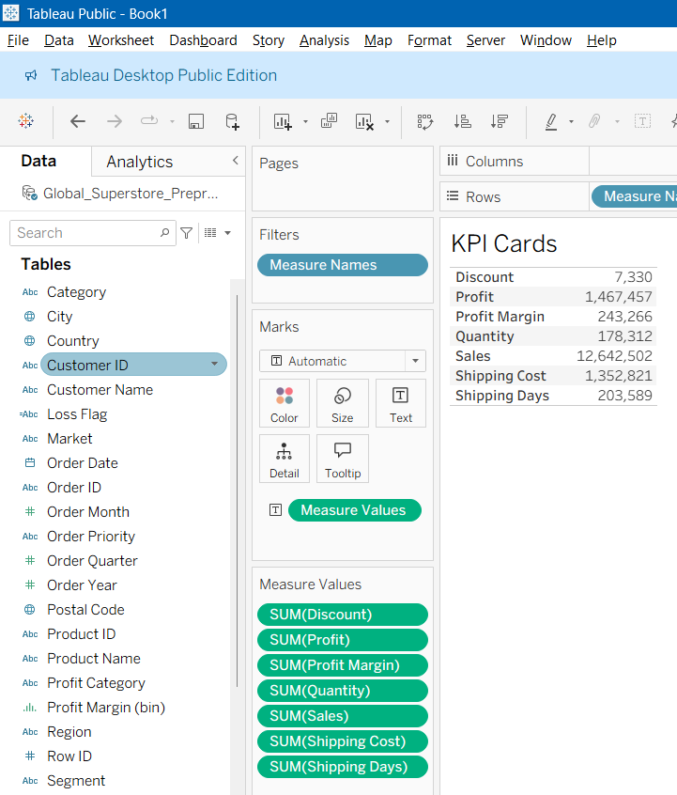

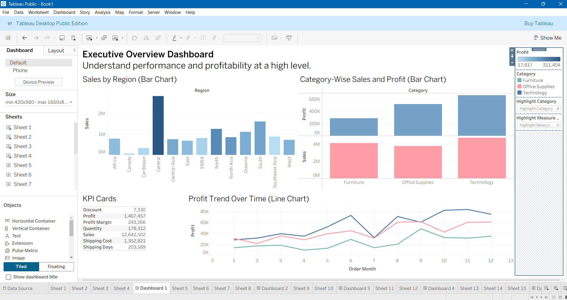

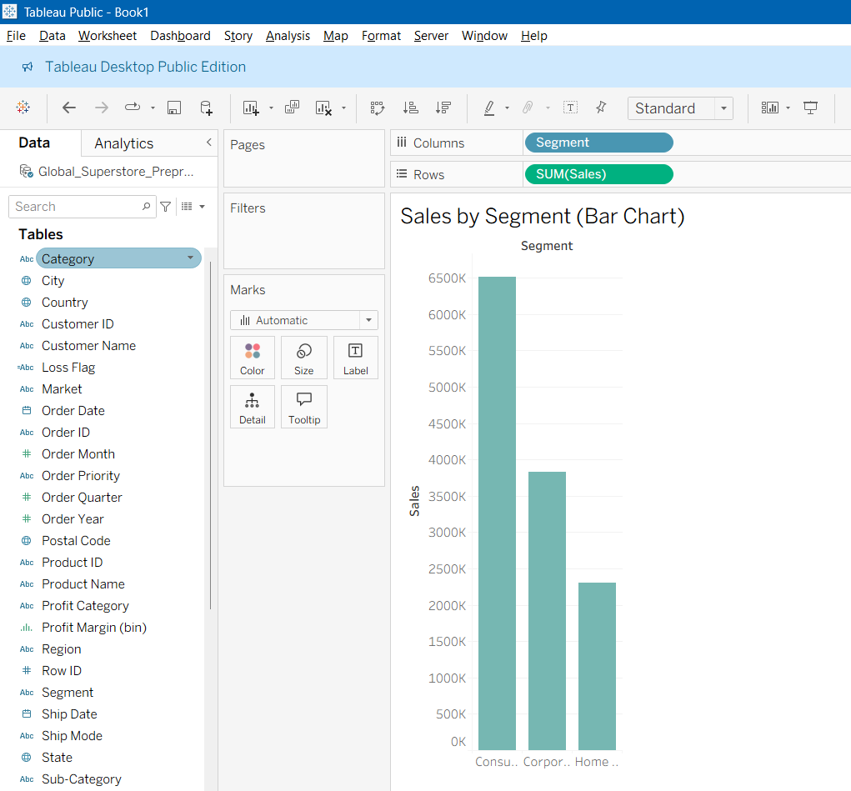

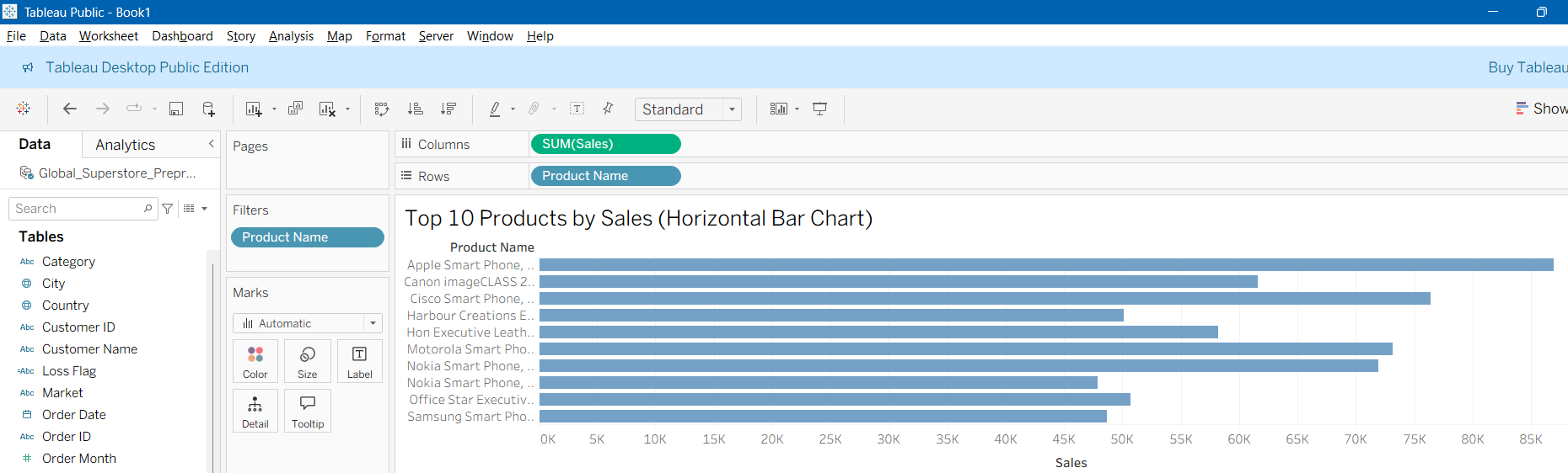

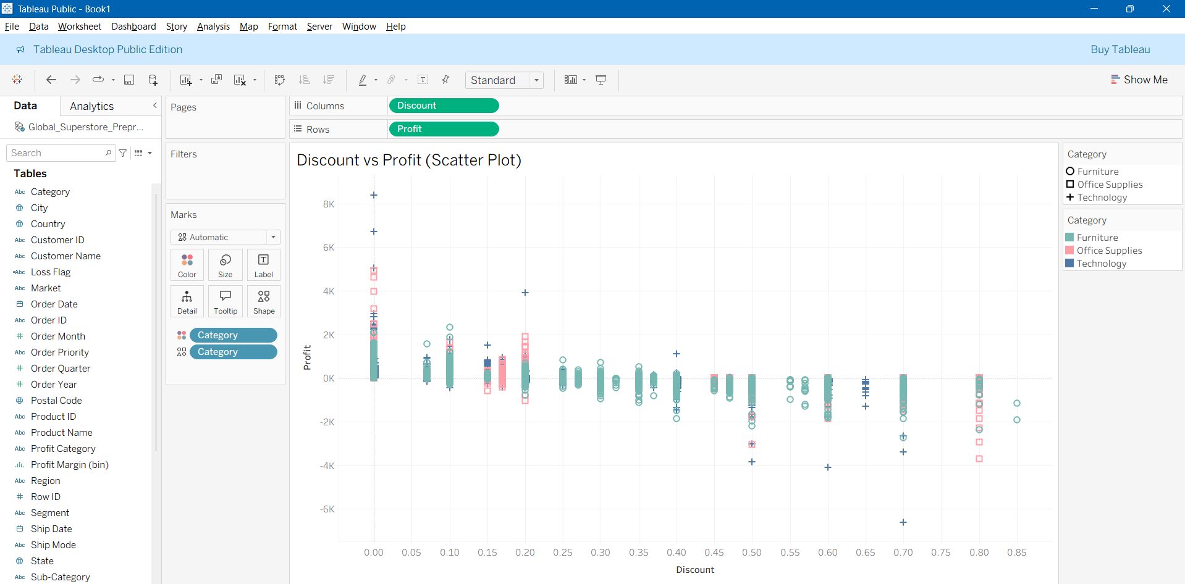

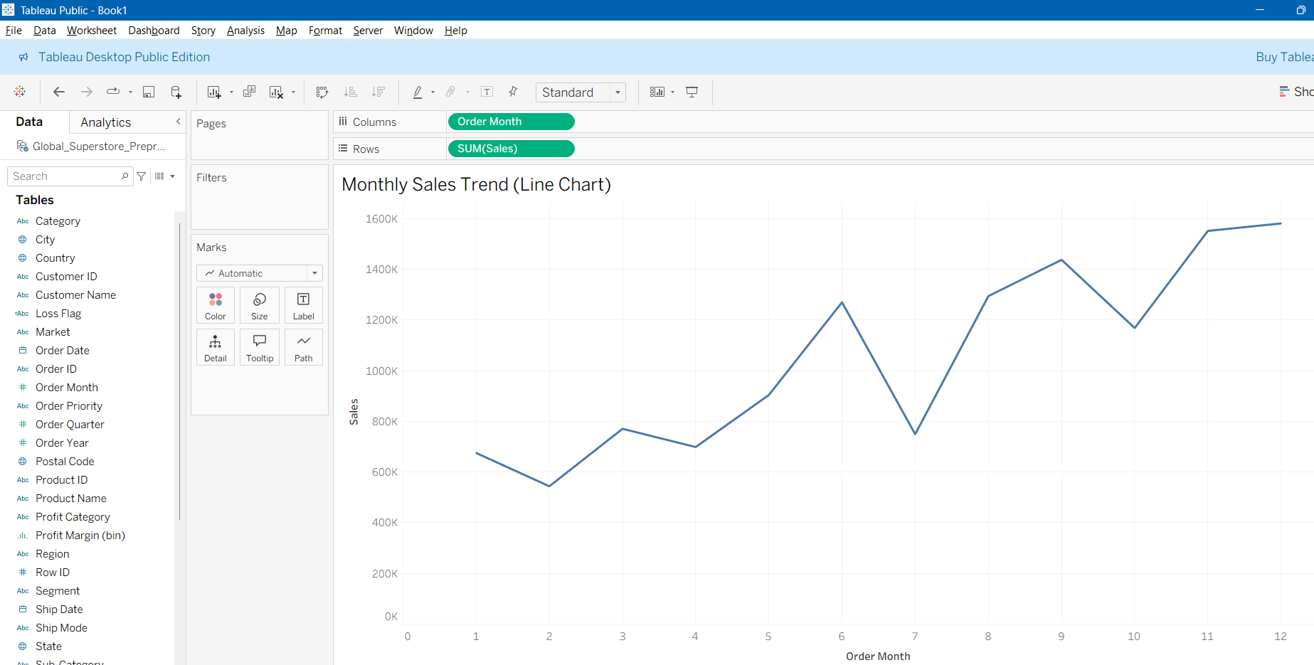

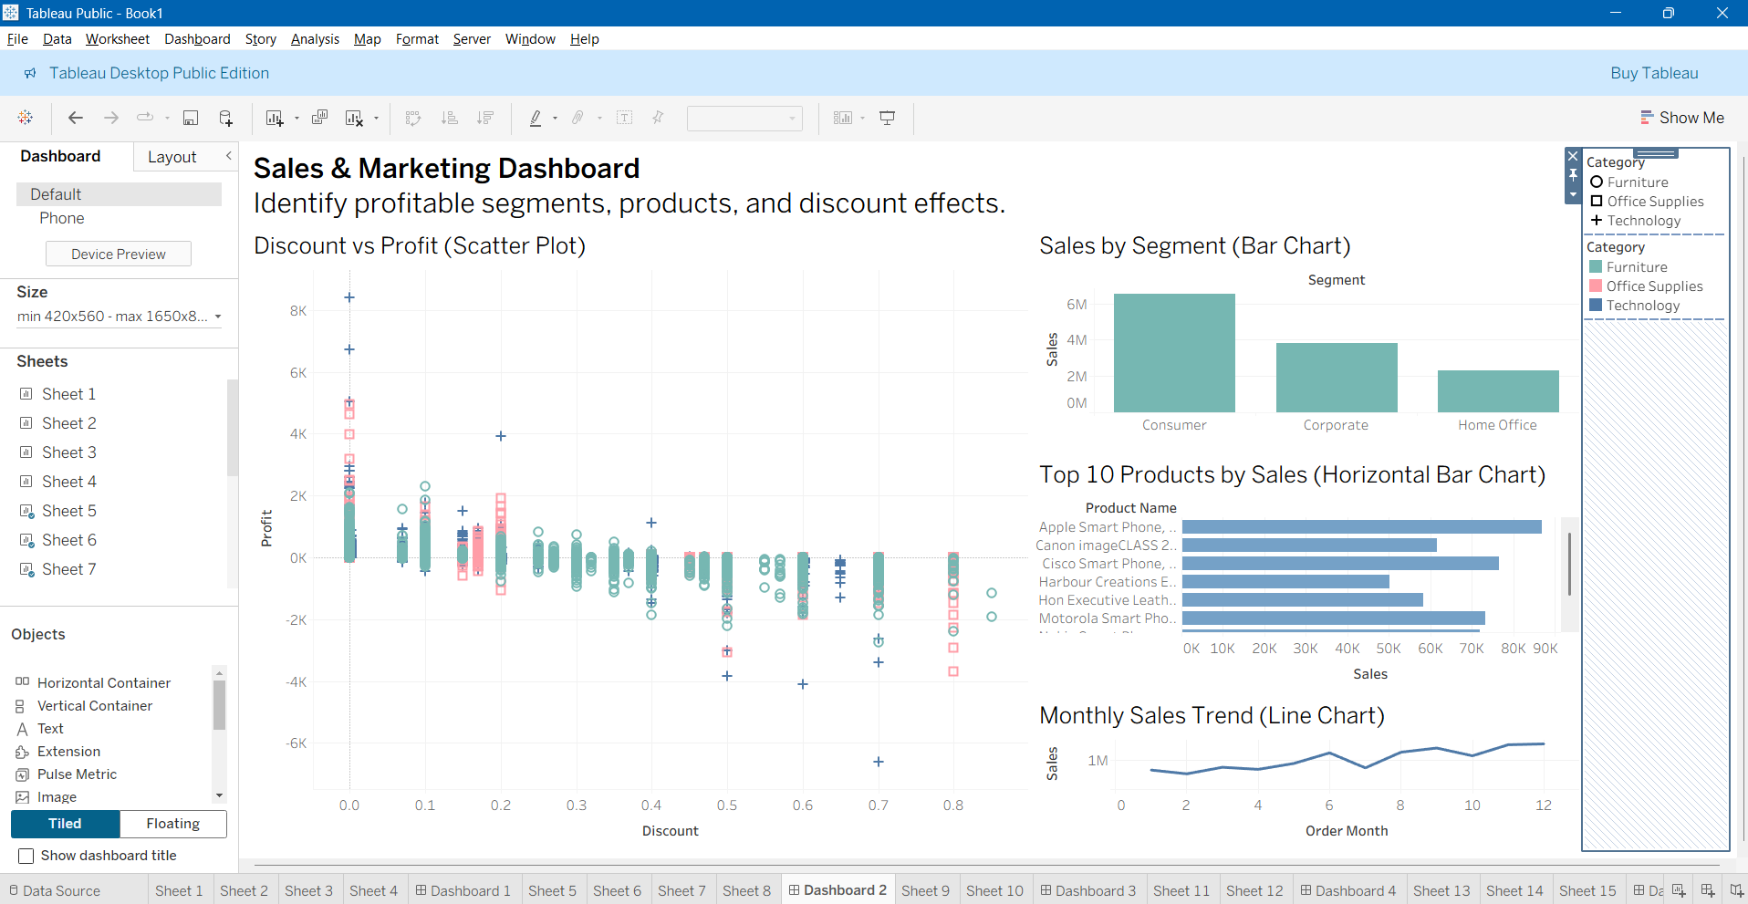

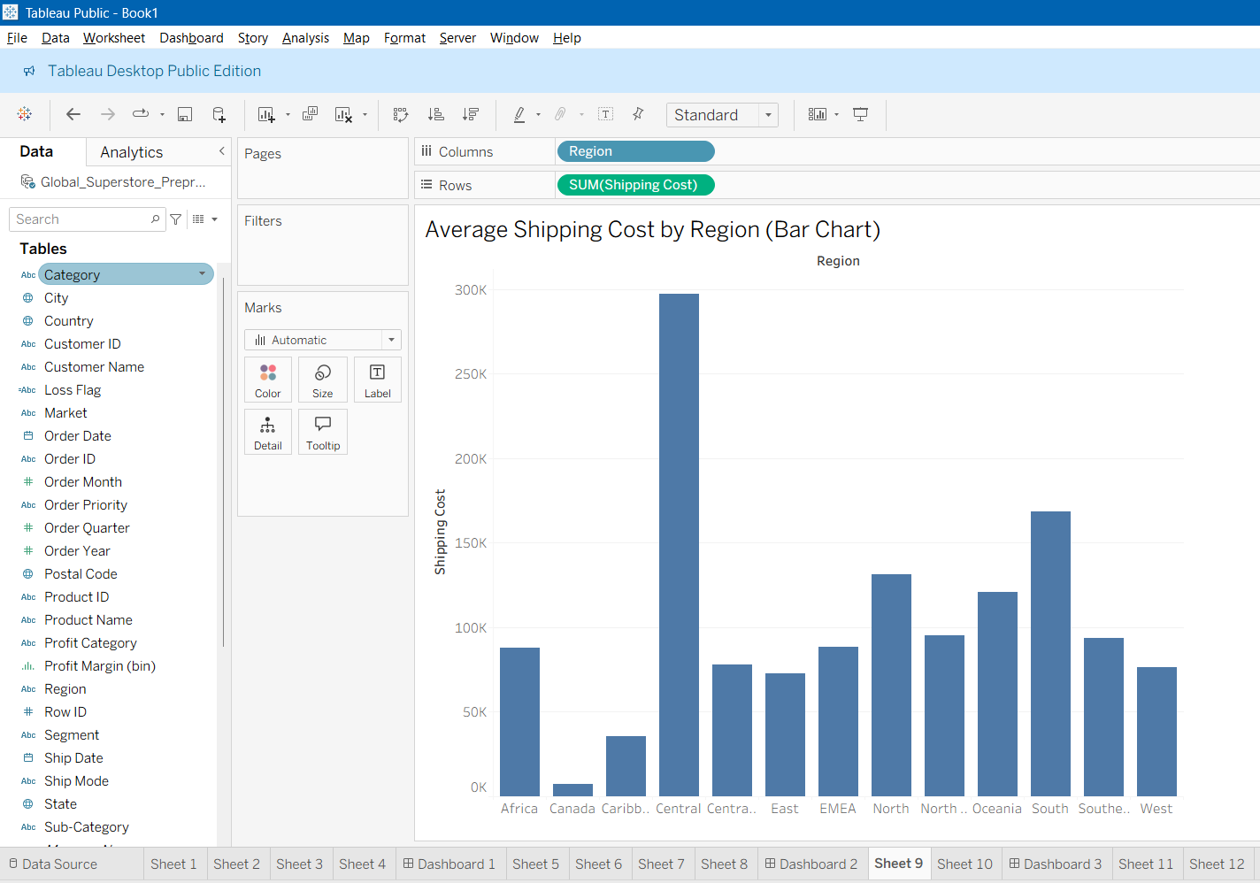
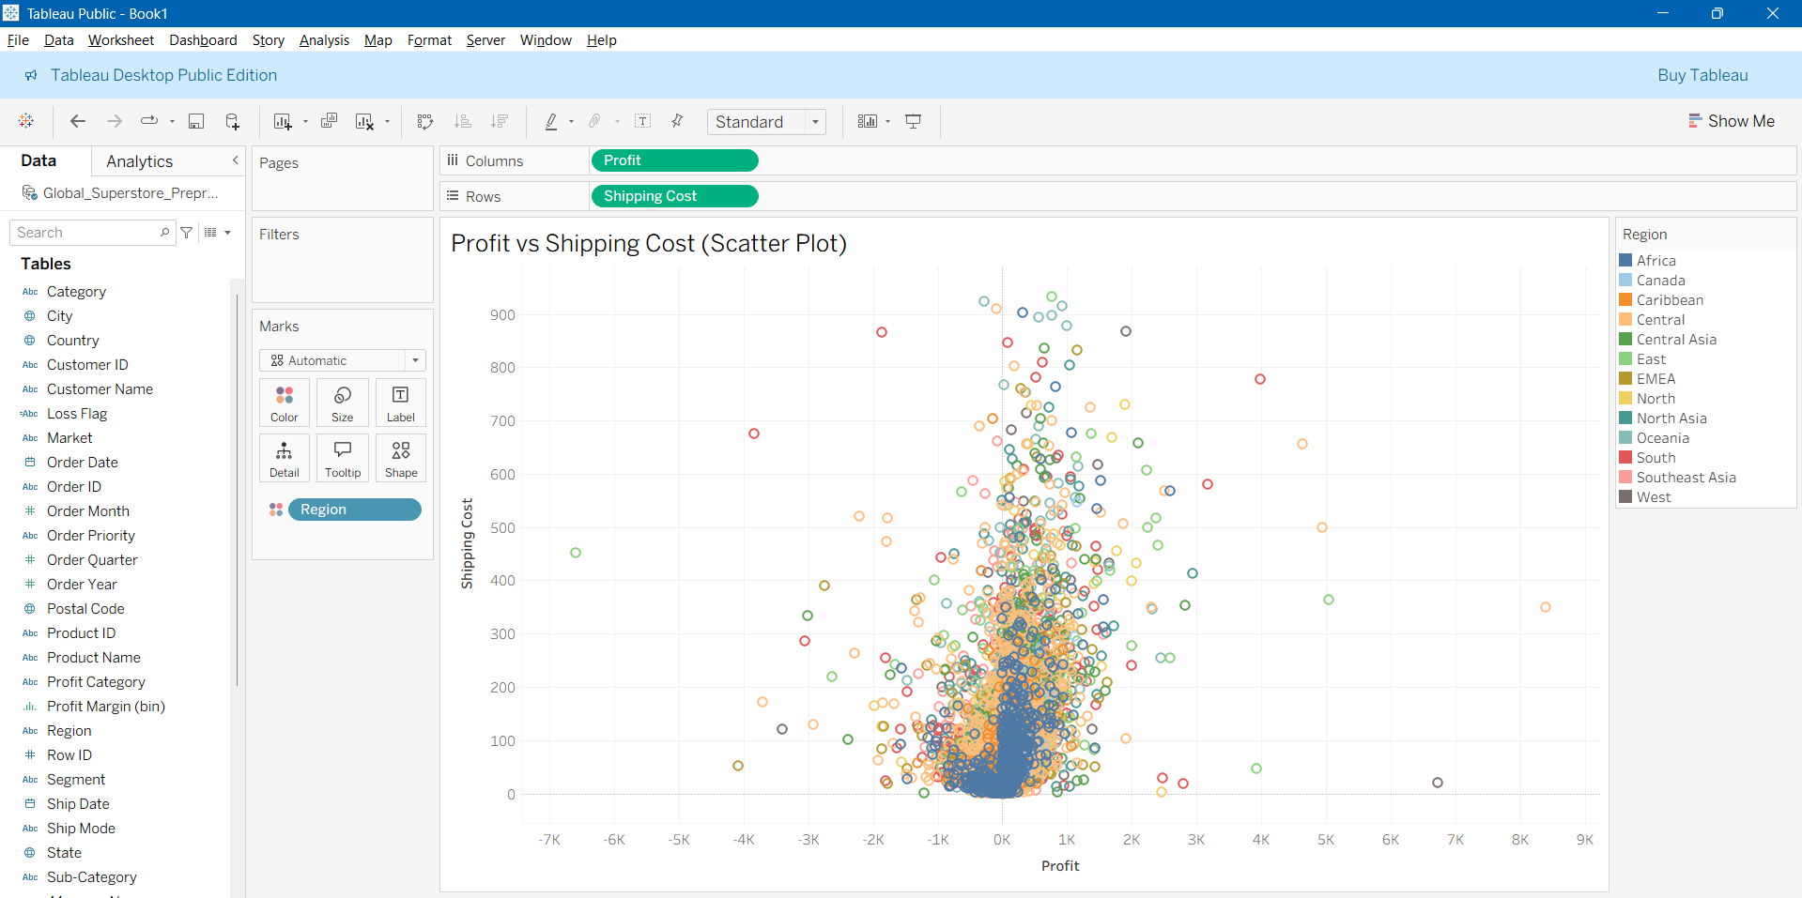

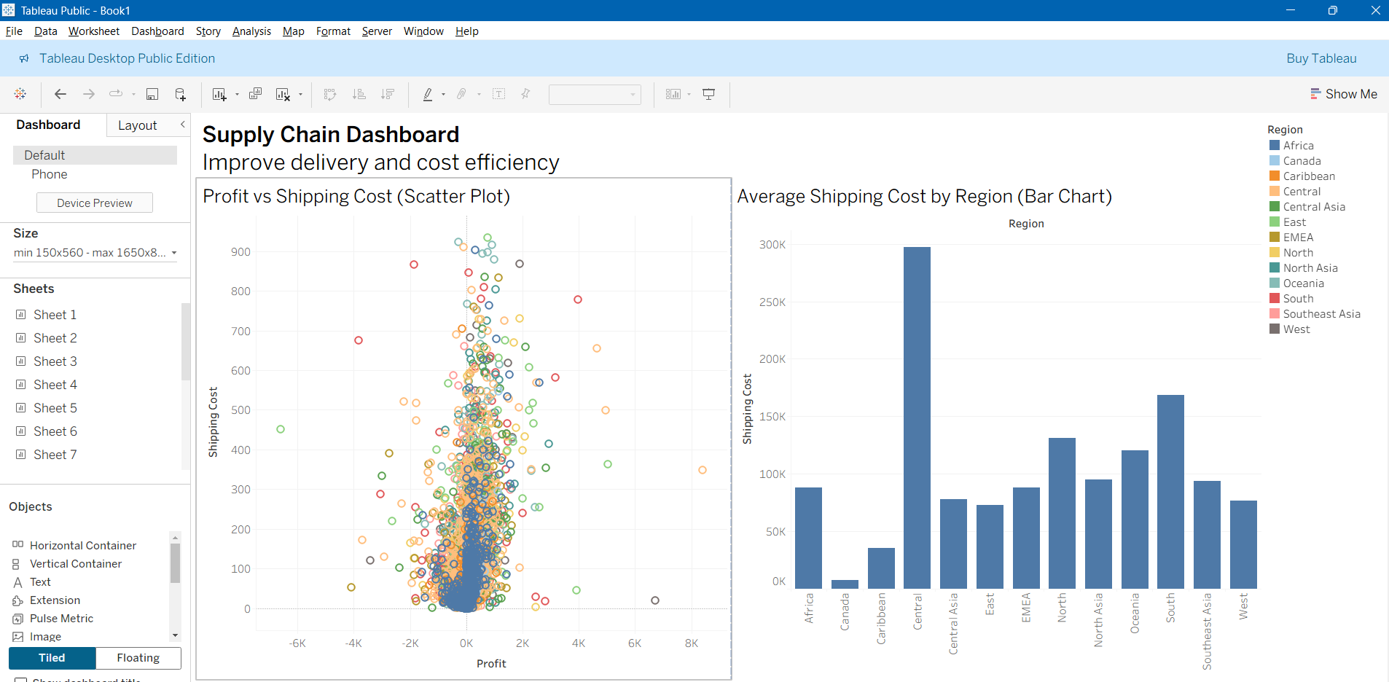
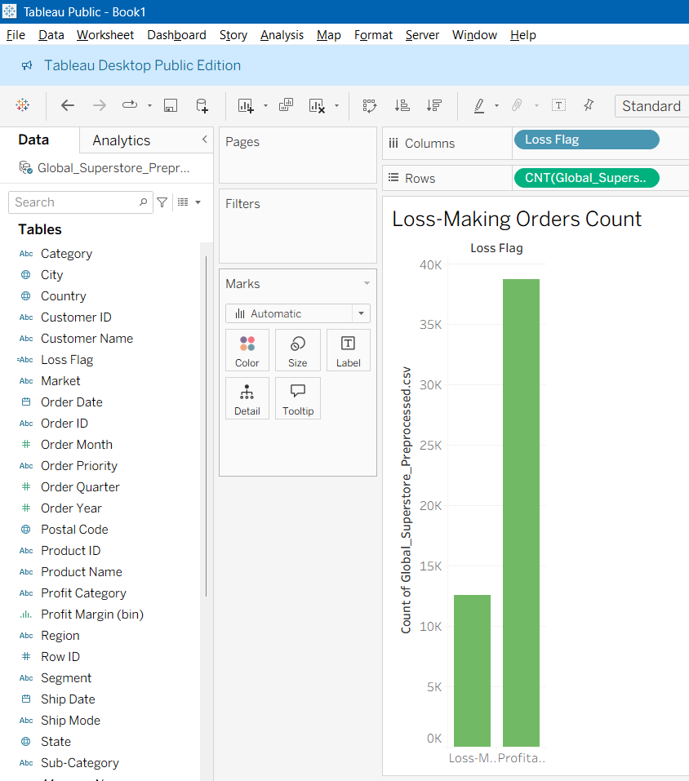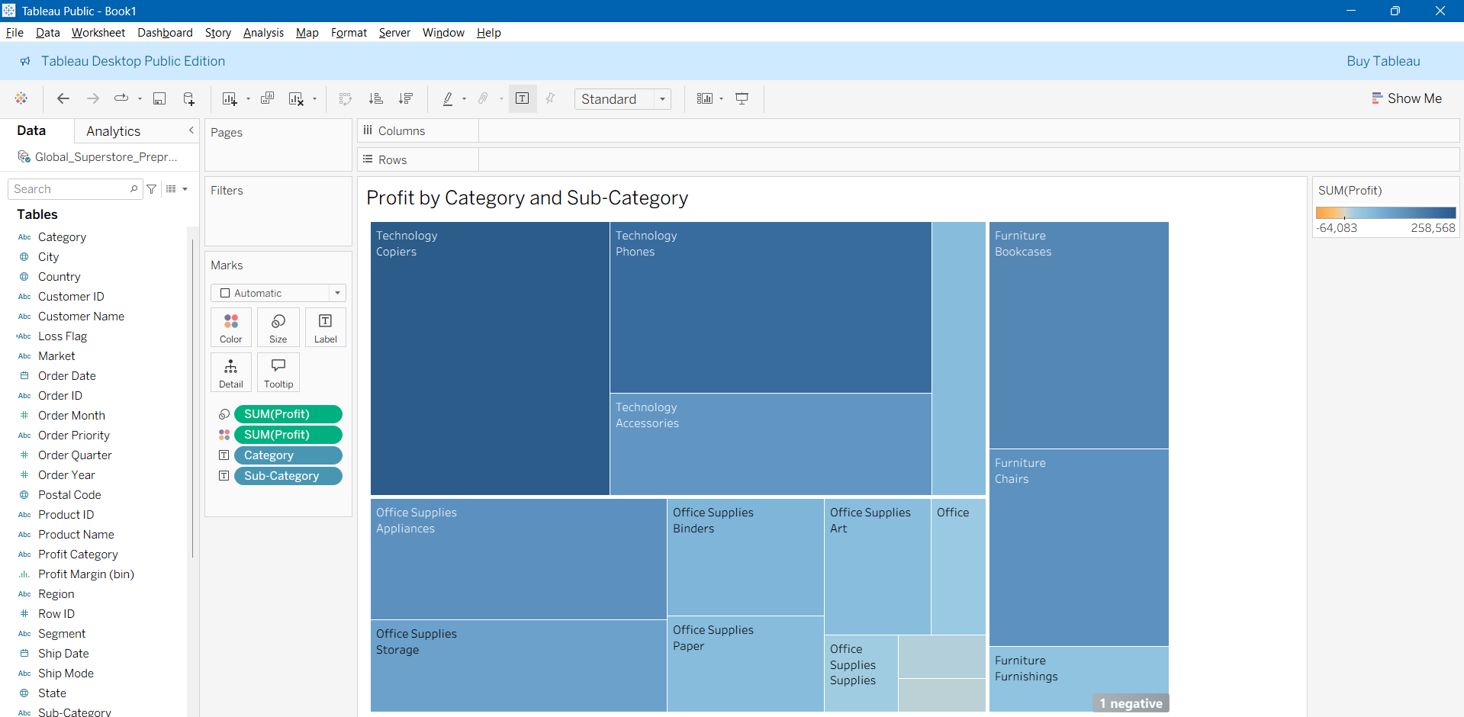
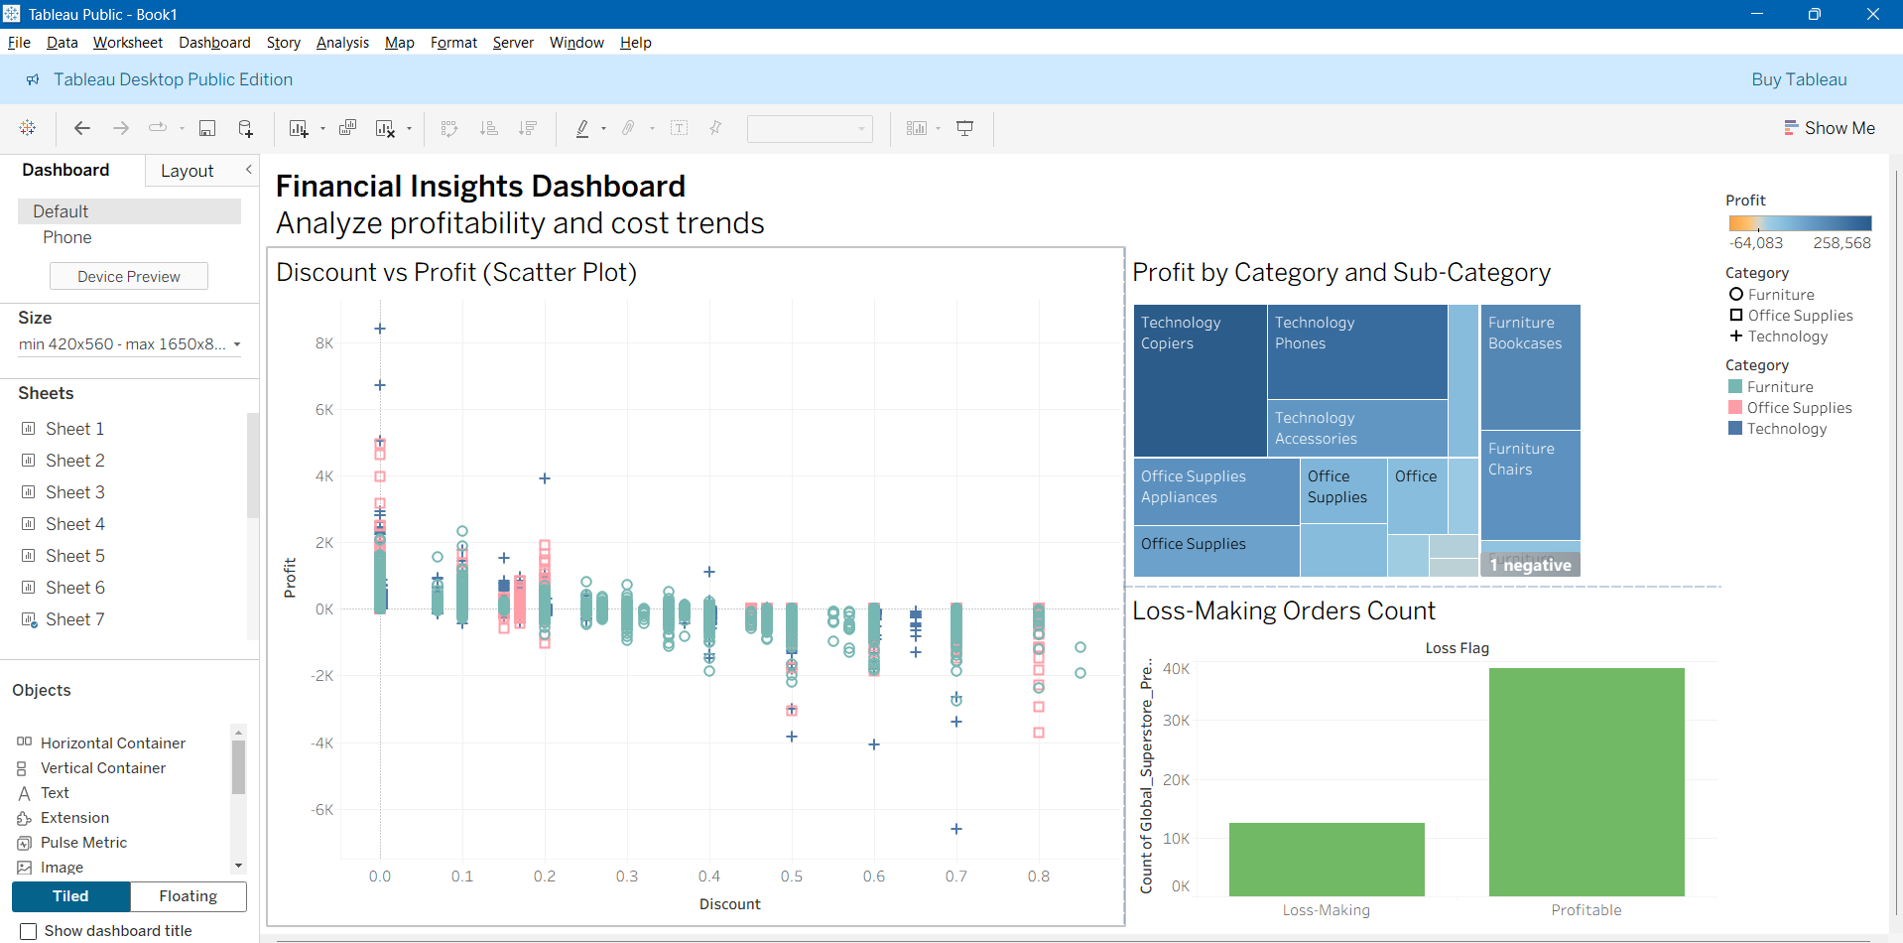

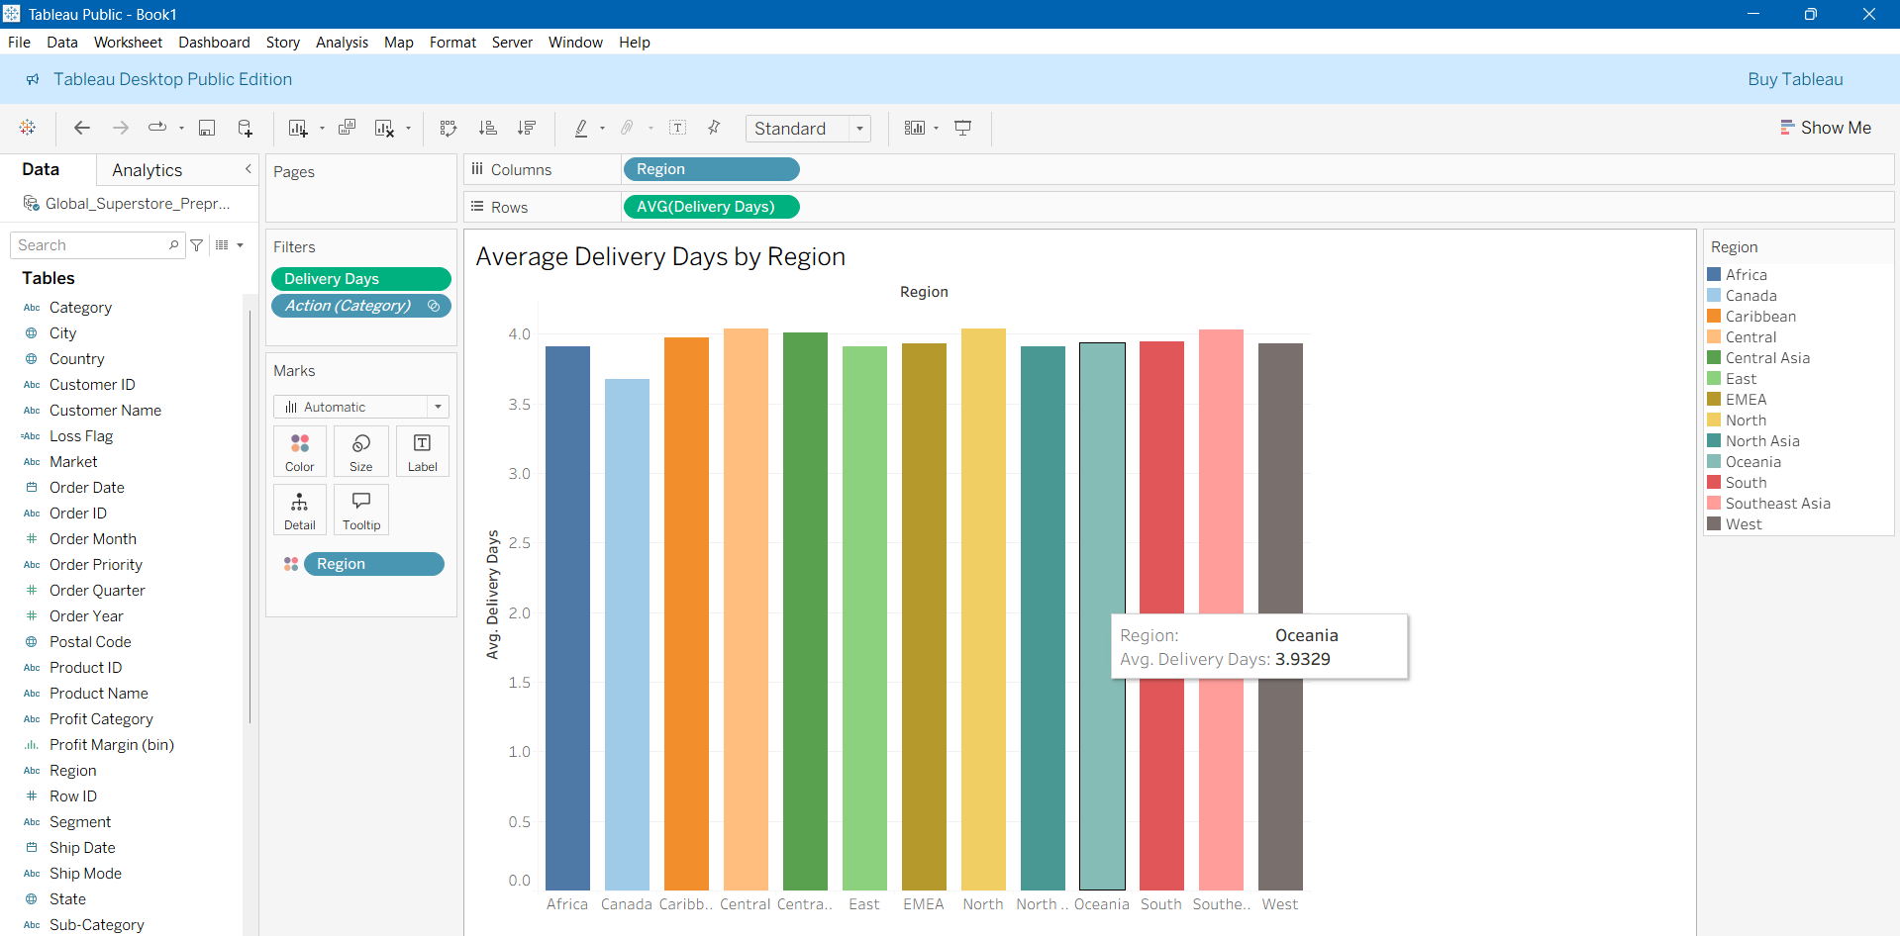
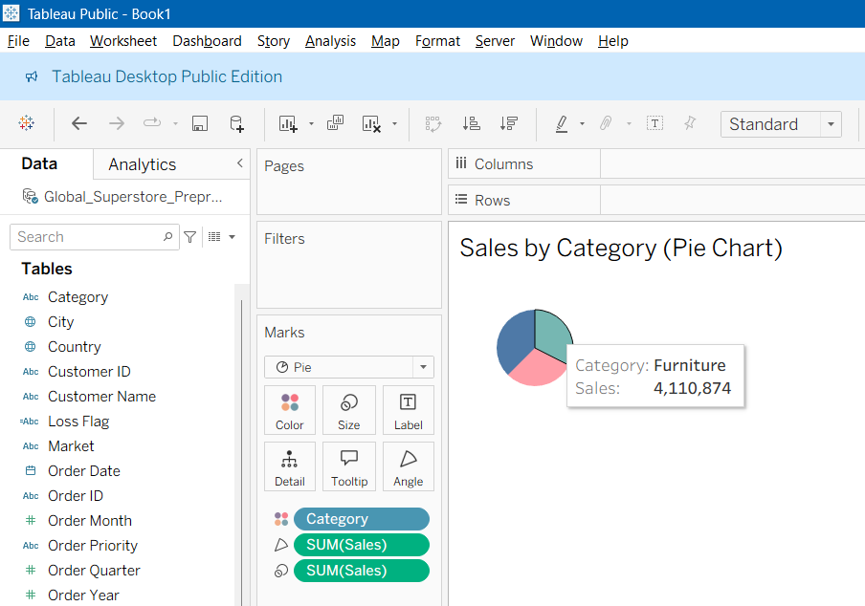

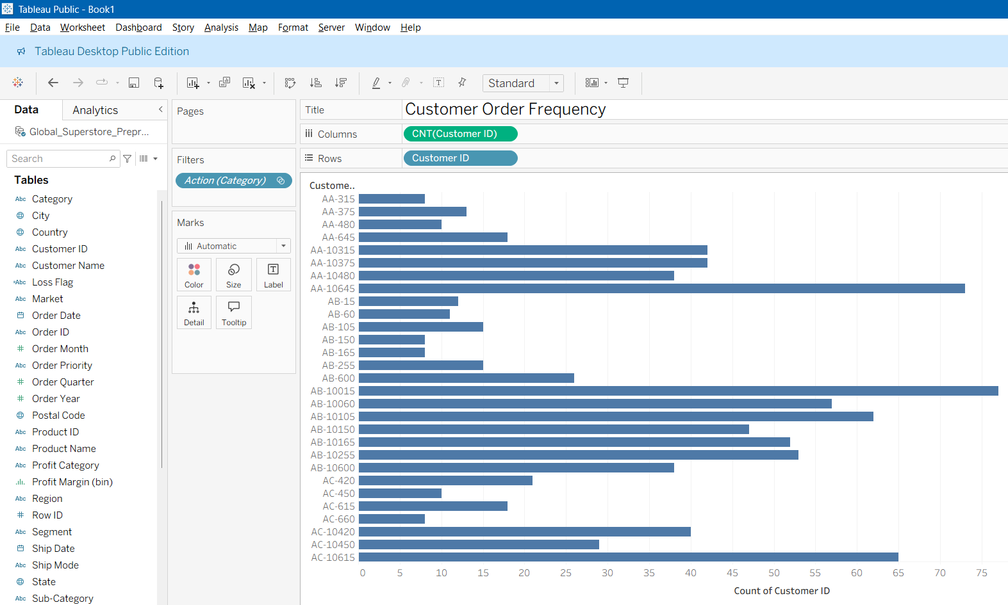
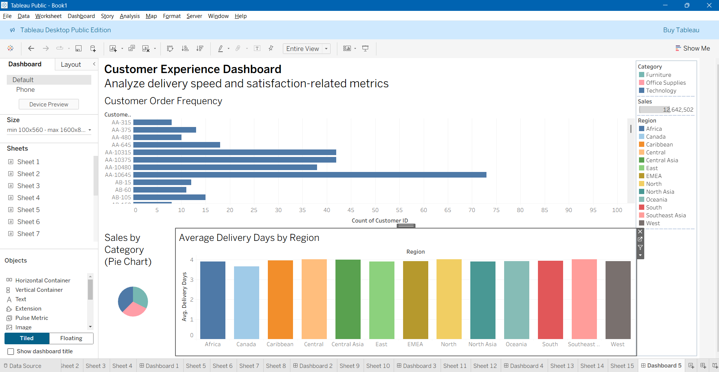
Q9. Classify/Predict/Cluster the data as per the need using and add corresponding plots/charts in the dashboard

import pandas as pd
import numpy as np
import matplotlib.pyplot as plt
import seaborn as sns
from sklearn.model_selection import train_test_split
from sklearn.preprocessing import LabelEncoder, StandardScaler
from sklearn.tree import DecisionTreeClassifier
from sklearn.linear_model import LinearRegression
from sklearn.cluster import KMeans
from sklearn.metrics import classification_report, confusion_matrix, accuracy_score
from sklearn.metrics import mean_squared_error, r2_score, mean_absolute_error
import warnings
warnings.filterwarnings('ignore')

# ============================================================================
# Load Data
# ============================================================================

df = pd.read_csv('Global_Superstore_Preprocessed.csv', encoding='latin-1')
print(f"Loaded {len(df)} rows")
print(df.head())
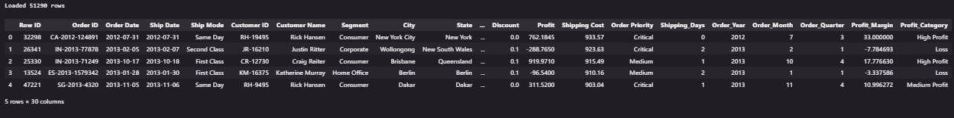
# ============================================================================
# Part 1: Classification - Predict Profit Category
# ============================================================================

print("\nPART 1: CLASSIFICATION - PREDICT PROFIT CATEGORY")

classification_features = ['Sales', 'Quantity', 'Discount', 'Shipping Cost',
'Category', 'Segment', 'Ship Mode']
target = 'Profit_Category'

df_class = df[classification_features + [target]].copy().dropna()
print(f"Dataset size: {len(df_class)} rows")

# Encode categorical variables
le_dict = {}
for col in ['Category', 'Segment', 'Ship Mode']:
le = LabelEncoder()
df_class[col] = le.fit_transform(df_class[col])
le_dict[col] = le

le_target = LabelEncoder()
df_class[target] = le_target.fit_transform(df_class[target])
print("Categorical variables encoded")

# Split data
X = df_class[classification_features]
y = df_class[target]
X_train, X_test, y_train, y_test = train_test_split(X, y, test_size=0.2, random_state=42, stratify=y)

# Train Decision Tree Classifier
dt_classifier = DecisionTreeClassifier(max_depth=10, min_samples_split=20,
min_samples_leaf=10, random_state=42)
dt_classifier.fit(X_train, y_train)
y_pred = dt_classifier.predict(X_test)

# Evaluate model
accuracy = accuracy_score(y_test, y_pred)
print(f"\nModel Accuracy: {accuracy:.2%}")

print("\nClassification Report:")
print(classification_report(y_test, y_pred, target_names=le_target.classes_))
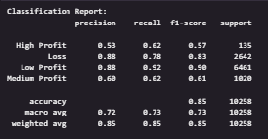
# Confusion Matrix
cm = confusion_matrix(y_test, y_pred)
plt.figure(figsize=(10, 8))
sns.heatmap(cm, annot=True, fmt='d', cmap='Blues',
xticklabels=le_target.classes_,
yticklabels=le_target.classes_)
plt.title('Confusion Matrix - Profit Category Classification', fontsize=14, fontweight='bold')
plt.ylabel('Actual')
plt.xlabel('Predicted')
plt.tight_layout()
plt.show()

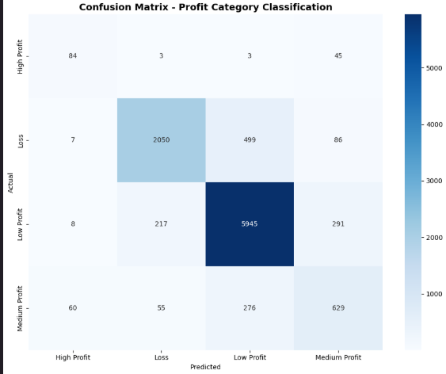
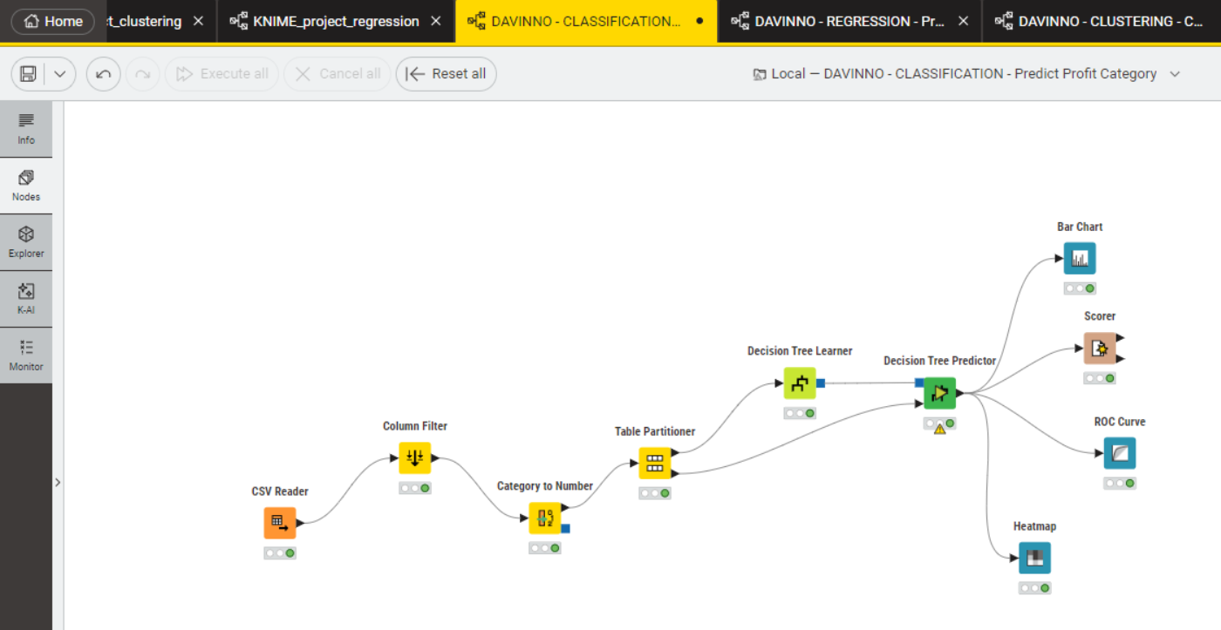
# ============================================================================
# Part 2: Prediction - Forecast Sales
# ============================================================================

print("\nPART 2: PREDICTION - FORECAST SALES")

prediction_features = ['Quantity', 'Discount', 'Shipping Cost',
'Category', 'Segment', 'Ship Mode']
target_pred = 'Sales'

df_pred = df[prediction_features + [target_pred]].copy().dropna()
print(f"Dataset size: {len(df_pred)} rows")

# Encode categorical variables
le_dict_pred = {}
for col in ['Category', 'Segment', 'Ship Mode']:
le = LabelEncoder()
df_pred[col] = le.fit_transform(df_pred[col])
le_dict_pred[col] = le

print("Categorical variables encoded")

# Split data
X_pred = df_pred[prediction_features]
y_pred_target = df_pred[target_pred]
X_train_pred, X_test_pred, y_train_pred, y_test_pred = train_test_split(
X_pred, y_pred_target, test_size=0.2, random_state=42)

# Normalize features
scaler = StandardScaler()
X_train_scaled = scaler.fit_transform(X_train_pred)
X_test_scaled = scaler.transform(X_test_pred)
print("Features normalized")

# Train Linear Regression model
lr_model = LinearRegression()
lr_model.fit(X_train_scaled, y_train_pred)
y_pred_sales = lr_model.predict(X_test_scaled)

# Evaluate model
r2 = r2_score(y_test_pred, y_pred_sales)
mae = mean_absolute_error(y_test_pred, y_pred_sales)
rmse = np.sqrt(mean_squared_error(y_test_pred, y_pred_sales))

print(f"\nR² Score: {r2:.4f}")
print(f"Mean Absolute Error: ${mae:.2f}")
print(f"Root Mean Squared Error: ${rmse:.2f}")


# Visualization: Actual vs Predicted & Error Distribution
fig, axes = plt.subplots(1, 2, figsize=(15, 6))

axes[0].scatter(y_test_pred, y_pred_sales, alpha=0.5, s=10)
axes[0].plot([y_test_pred.min(), y_test_pred.max()],
[y_test_pred.min(), y_test_pred.max()],
'r--', lw=2, label='Perfect Prediction')
axes[0].set_xlabel('Actual Sales ($)', fontsize=12)
axes[0].set_ylabel('Predicted Sales ($)', fontsize=12)
axes[0].set_title('Actual vs Predicted Sales', fontsize=14, fontweight='bold')
axes[0].legend()
axes[0].grid(True, alpha=0.3)

residuals = y_test_pred - y_pred_sales
axes[1].hist(residuals, bins=50, edgecolor='black', alpha=0.7, color='steelblue')
axes[1].set_xlabel('Prediction Error ($)', fontsize=12)
axes[1].set_ylabel('Frequency', fontsize=12)
axes[1].set_title('Prediction Error Distribution', fontsize=14, fontweight='bold')
axes[1].axvline(x=0, color='r', linestyle='--', linewidth=2)
axes[1].grid(True, alpha=0.3)

plt.tight_layout()
plt.show()
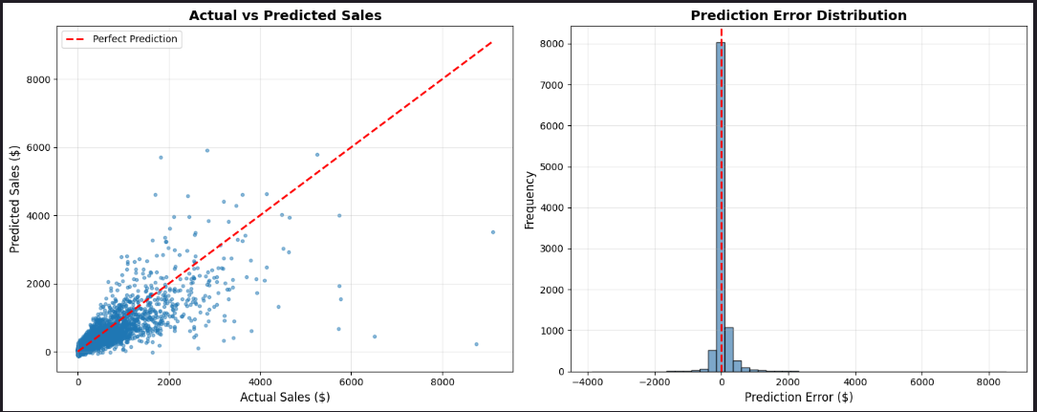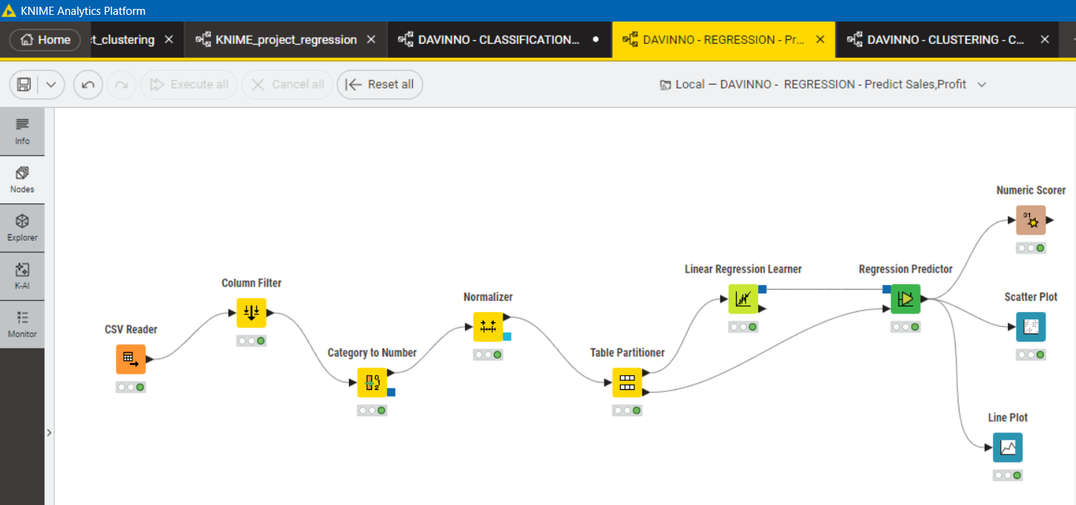
# ============================================================================
# Part 3: Clustering - Customer Segmentation
# ============================================================================

print("\nPART 3: CLUSTERING - CUSTOMER SEGMENTATION")

# Aggregate customer data
customer_data = df.groupby('Customer ID').agg({
'Sales': 'sum',
'Profit': 'sum',
'Quantity': 'sum',
'Order ID': 'count',
'Discount': 'mean'
}).reset_index()

customer_data.columns = ['Customer_ID', 'Total_Sales', 'Total_Profit',
'Total_Quantity', 'Order_Count', 'Avg_Discount']

print(f"Analyzing {len(customer_data)} customers")
print(customer_data.head())
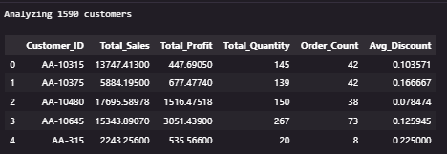
# Prepare clustering features
clustering_features = ['Total_Sales', 'Total_Profit', 'Total_Quantity',
'Order_Count', 'Avg_Discount']
X_cluster = customer_data[clustering_features]
scaler_cluster = StandardScaler()
X_cluster_scaled = scaler_cluster.fit_transform(X_cluster)
print("Features normalized")

# Perform K-Means clustering
optimal_k = 4
kmeans = KMeans(n_clusters=optimal_k, random_state=42, n_init=10)
customer_data['Cluster'] = kmeans.fit_predict(X_cluster_scaled)

# Assign meaningful names to clusters
cluster_summary = customer_data.groupby('Cluster')[clustering_features].mean()
sorted_clusters = cluster_summary.sort_values('Total_Sales').index
cluster_names = {0: 'Low Value', 1: 'Medium Value', 2: 'High Value', 3: 'VIP'}
cluster_mapping = {cluster: cluster_names[i] for i, cluster in enumerate(sorted_clusters)}
customer_data['Cluster_Name'] = customer_data['Cluster'].map(cluster_mapping)

print(f"\nCreated {optimal_k} customer segments:")
for cluster_name in sorted_clusters:
cluster_label = cluster_mapping[cluster_name]
cluster_info = customer_data[customer_data['Cluster'] == cluster_name]
print(f" {cluster_label}: {len(cluster_info)} customers "
f"(Avg Sales: ${cluster_info['Total_Sales'].mean():.2f})")
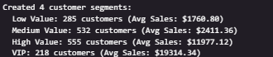

# Cluster characteristics
cluster_summary_full = customer_data.groupby('Cluster_Name')[clustering_features].mean()
cluster_summary_full['Customer_Count'] = customer_data.groupby('Cluster_Name').size()
print("\nCluster Characteristics:")
print(cluster_summary_full.round(2))
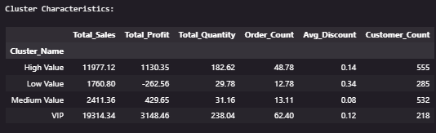
# Visualization: Multiple cluster views
fig, axes = plt.subplots(2, 2, figsize=(16, 12))

# Sales vs Profit scatter
scatter = axes[0, 0].scatter(customer_data['Total_Sales'],
customer_data['Total_Profit'],
c=customer_data['Cluster'],
cmap='viridis',
s=50, alpha=0.6)
axes[0, 0].set_xlabel('Total Sales ($)', fontsize=12)
axes[0, 0].set_ylabel('Total Profit ($)', fontsize=12)
axes[0, 0].set_title('Customer Segments: Sales vs Profit', fontsize=14, fontweight='bold')
plt.colorbar(scatter, ax=axes[0, 0], label='Cluster')

# Pie chart of customer distribution
cluster_counts = customer_data['Cluster_Name'].value_counts()
axes[0, 1].pie(cluster_counts, labels=cluster_counts.index, autopct='%1.1f%%',
colors=sns.color_palette('viridis', len(cluster_counts)))
axes[0, 1].set_title('Customer Distribution by Segment', fontsize=14, fontweight='bold')

# Orders vs Sales scatter
scatter2 = axes[1, 0].scatter(customer_data['Order_Count'],
customer_data['Total_Sales'],
c=customer_data['Cluster'],
cmap='viridis',
s=50, alpha=0.6)
axes[1, 0].set_xlabel('Number of Orders', fontsize=12)
axes[1, 0].set_ylabel('Total Sales ($)', fontsize=12)
axes[1, 0].set_title('Orders vs Sales by Segment', fontsize=14, fontweight='bold')
plt.colorbar(scatter2, ax=axes[1, 0], label='Cluster')

# Average sales by segment
cluster_summary_plot = customer_data.groupby('Cluster_Name')['Total_Sales'].mean().sort_values()
axes[1, 1].barh(cluster_summary_plot.index, cluster_summary_plot.values,
color=sns.color_palette('viridis', len(cluster_summary_plot)))
axes[1, 1].set_xlabel('Average Sales ($)', fontsize=12)
axes[1, 1].set_title('Average Sales by Customer Segment', fontsize=14, fontweight='bold')

plt.tight_layout()
plt.show()
